

<Towards better tourism>

<SOI-2020-2020-0007>

Date of Submission: 02-02-2021

Submitted By:

<SOI-2020-0049>

|  |  |
| --- | --- |
| <18009531> | <Chua Kai Zhen Jolene> |
| <18037607> | <Tan Tian Gan> |
| <18009282> | <Yee Han Yew> |
| <18009652> | <Muhammad Syukry Salim> |

# ACKNOWLEDGEMENTS

***Section Explanation:*** *You may want to thank those individuals who have assisted your team during your project. You could also mention any organizations that have helped you while you have been carrying out the project.*

*During the process of our project, we would like to sincerely thank Dr. Tan Lee Kiat for guiding us and giving us advice on how to improve every week. Dr. Tan is always clear in instructions and he would worry if any of the work we produced is not up to standard. He is really kind in heart and professional when it comes to evaluating our work. We had to obtain the Tableau License for our project and he assisted us during the process of it as it was quite complicated. We would also like to thank the 2 evaluators (Marlina Mastor and Joshua Tan) during our mid-term evaluation for critiquing our work and giving feedback on how we can make further changes that would meet their standards and do well for the project. We would also like to thank Tableau for giving us a free 1-year license so that we are able to use the software and smoothly finish our project. Tableau is a software that is very flexible which saves us a lot of trouble since their functions are very good to use. We all have also used Tableau before in the module called Business Applications which made us more familiar and comfortable with this software. Hence, we are really grateful to be able to use this software for our final year project. Lastly, we would also like to thank Faci Yong Yoke Fong for creating this project as we feel that this project is really suitable as a final year project. It is challenging as we have to source for our own dataset and analyse it while producing a credible visualisation table and story while giving recommendations. It was a pleasant experience and we feel honoured to be given a chance to expand our knowledge on data analysis through this project.*

**TABLE OF CONTENTS**

ACKNOWLEDGEMENTS 2

ABSTRACT 4

1 Introduction 5

2 Project Specification and Plan 6

2.1 Project Overview 6

2.2 Functional Requirements 6

2.3 Project Plan 7

3 Business Analysis 8

3.1 Business Issues 8

3.2 Market Analysis 8

3.3 Business Solutions 8

4 System Design and Implementation 9

4.1 System Architecture 9

4.2 Detailed System Design 9

5 System Testing 10

6 User and Technical Documentations 11

6.1 User Documentation/Guide/Manual 11

6.2 Technical Documentation (Installation guide/Manual) 11

7 Conclusions 12

References 13

Appendices 14

Project Poster 15

# ABSTRACT

***Section Explanation:*** *The executive summary is also known as an abstract of your report. It is a brief summary of the report’s contents. It should be about half a page long (should be about 250 words or less). The reader should be able to understand what the project is about, how it was undertaken and what was accomplished. The abstract should answer the following questions:*

* *What is the project about?*
* *How is the project implemented?*
* *What did the project accomplish?*
* *Final status of the project and recommendations (if any)?*

*The project is mainly about extracting raw data for Tripadvisor website and cleansing it to become processed data that are ready to perform analysis on. Creating good management information involves incorporating the raw data with the business rules in the context of TripAdvisor. The project should encourage desired actions and highlight potential problems and risks.. The project is firstly implemented by sourcing for suitable scraping tools for data extraction. After each member tried out a few different softwares, our team came to a conclusion of using Data Miner Pro. We then went on to scraping the necessary datas from Tripadvisor from the 4 different domains that we are doing. The data scraping process was the most time-consuming part. After getting sufficient data, we had to cleanse and organise it to be able to start performing different analysis techniques on Tableau. We used the data to produce visualisation tables and dashboards whereby the motive is clear and is easy to understand. It requires a lot of thinking process as to what a tourist would want to see from the table and fulfil TripAdvisor's motive. Putting ourselves into an outsider’s shoes and thinking from that perspective as to what one would want to see in a package from TripAdvisor. The project accomplished on producing insights and information for TripAdvisor that would be useful to show tourists about the main purpose of each domain and the distinctive one out of all the different ones.*

# Introduction

***Section Explanation:*** *The introduction should tell the reader what your project is about. The introduction should answer the following questions:*

* *What exactly is the problem that your project is trying to solve?*
* *Why is this problem important to solve? This is the motivation of the project.*
* *What are the major tasks and deliverables of the project? This is the project scope.*
* *How have you solved the problem? This is your approach. You should expand on this in the later sections (project strategy, plan and design)*
* *What are the conditions under which your solution is applicable? This is where you list the assumptions made, if any.*
* *What are the main results? This is where you list the main deliverable points.*

*The problem that we are trying to solve is how raw data from TripAdvisor can be processed into usable information. Our insights are based on the processed data that we derived from the four domains on TripAdvisor which are hotels, transportation, malls and attractions. The reason why this problem is important to solve is that studies suggest that only 10% of raw data is necessary to answer everyday questions from business operations. Sometimes, having too much information would distract the decision-making process. Hence, it proves that many of the raw data is not really needed and is a waste of time for management to look through everything. The raw data is only valuable if the information and insight extracted from it helps the business to make better decisions. The management information can be used to support decision-making by managers hence it is important for it to be useful.*

# Project Specification and Plan

***Section Explanation:*** *Students should read and understand the requirements in this section and set achievable deliverables with the Supervisor. Some of the deliverables that the students and Supervisors should agree upon before the start of the Project are listed below but not limited to:*

* *Extent of business analysis*
* *Extent of technical analysis, design and implementation*
* *Tools and techniques used in analysis*
* *Resources such as web servers etc.*
* *Optional items listed in this guidelines that can be omitted from the report*

*This section should be completed between 1st and 2nd meeting*

* *Project Overview*
* *Functional Requirements*
* *Project Plan*

## Project Overview

***Section Explanation:*** *This subsection should contain a brief description of the system being developed and its purpose, including information such as:*

* *Project Motivation (Why do the project? what are the benefits?)*
* *Project Objectives (What is the project trying to accomplish?)*
* *Project Scope (What are the major tasks and deliverables of the project?)*
* *Project Assumptions (Are there assumptions which are made regarding how the end deliverable will work, etc.?)*

*The motivation behind this project is that we get to further our understanding of how the usage of data scraping, data visualization and data analytic tools. The reason behind carrying out the project is an attempt to put our Business Intelligence skills to good use on an actual project after taking a module about business intelligence. The benefits is that we are learning to improve data quality, analysing data and showing data with visualization which are skills in demand in the job market. Business intelligence is a term generally used for the set of techniques and tools for the transformation of raw data into meaningful and useful information for business analysis purposes. The Project helps us to create our own insights from the data collected. With this data, we were able to form credible dashboards and stories in Tableau and present our findings.*

*The major task and deliverables of this project is to use the dataset that we have obtained from Tripadvisor and produce usable data that have been processed which are easy to view and understand without much explanation. This includes visualisation tables and predictive models.*

*The assumptions that were made is that our end deliverable which are the different storyboards would be presented in a TripAdvisor package. This package will be targeted to tourists who are looking to visit Singapore as it covers the 4 important domains of tourism. It shows the best and worst to visit in Singapore and recommendations if they were to visit Singapore. This includes hotels, shopping malls, transportations and attractions.*

## Functional Requirements

***Section Explanation:*** *This subsection should clearly specify the major functions the system should possess. Business rules or business requirements must be documented. Students are encouraged to use tools such as Use Case diagram to document the business requirements.*

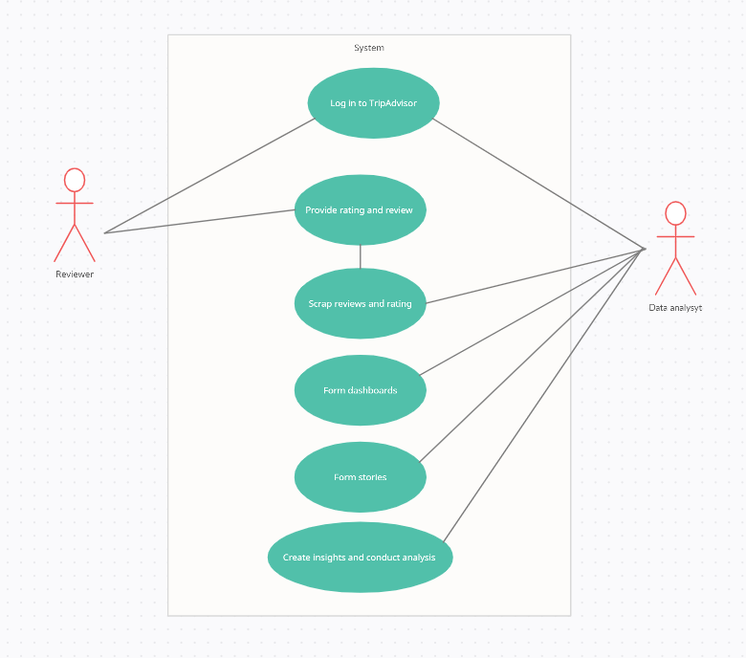

## Project Plan

***Section Explanation:*** *This subsection describes in detail the schedule, milestones and work allocation of each member of the team. Care must be taken to prepare this as each member of the team will be evaluated independently based on his/her contribution, effort, teamwork amongst other factors. This subsection will also serve as a basis where teams and supervisors can monitor progress being made. The use of MS Project is recommended.*

*In the Microsoft Project, you may include the following:*

* *List of tasks need to be assigned to a particular team member*
* *Ensure that there is adequate and fair involvement by each team member*
* *Project Plan must take into consideration the deliverables at specific milestone such as the 3 meetings*

*Week 1 – Each and every member was assigned different scraping software by Jolene to test and find out which program we would personally like to use as everybody has different preferences. It is ideal for one to be comfortable while using a software to scrap the data as it is a large size of dataset. Tian Gan had tested on Octoparse & ParseHub, Syukry had tested on Data Miner Pro & Helium Scraper, Galvin had tested on UiPath & Scraping Bot. Jolene had tested on WebHarvy, Octoparse, ParseHub & Data Miner Pro. Tian Gan had emailed ParseHub as he kept getting errors for a free plan, they replied a few days ago asking him to top-up for a better plan. Hence, we didn’t use it as well. We ended up concluding that all of us will use Data Miner Pro since it is free and the simplest to use.*

*Week 2 – We wrote down the Pros & Cons of each and every software that we have individually done and consolidate the data so that we all can view each other’s work and narrow down to the top 3 choices. We all then tried out the top 3 choices which were Octoparse, UiPath & Data Miner Pro. However, many of us faced error and difficulties while trying out Octoparse and hence we decided to not use it for our project. For UiPath, setting it was the most complicated process out of the 3 choices as the tutorial given was also an old video which has changed since. For Data Miner Pro, it was the easiest to set up as it is just adding an extension on google chrome. It took less than 5 minutes to install the software and we all liked how simple it was to use hence it was our data scraping choice.*

*Week 3 – On week 3, we were deciding the domains to use from TripAdvisor and I ended up assigning it to them as I was the team leader which makes it a faster process. I would see their preferences and assign accordingly, Tian Gan (Hotels), Syukry (Attractions), Jolene (Shopping Malls), Galvin (Transportation). Everyone got what they wanted at first however for Galvin, he had to change from Airlines to Transportations as he kept facing duplication errors repeatedly which was very unfortunate.*

*Week 4 – During week 4, we have already started to scrape data from TripAdvisor and we have documented it for future use. We also researched on data mining tools such as KNIME & Orange so as to extract the keywords from the reviews. Jolene and Tian Gan had actually got a few PDFs from Orange Software on the word counts of reviews and keywords of each shopping mall which was really time-consuming, but it didn’t come to use in the end as it was difficult to handle with Tableau. We all emailed Tableau to get the licence to be able to continue with our project.*

*Week 5 – During week 5, we were still scraping our individual domains to get sufficient data. We had to re-email Tableau to rush them on our licence since we faced some difficulties whereby provided valid proof that we are students of Republic Polytechnic but it got rejected for the first application. It only got through during the second application when we sent a screenshot of the RPConnect E-Pass. During the week, The team also had to recap, watch videos & tutorials on Tableau as it has been quite some since using the software.*

*Week 6 – Up till this week, all of us were still scraping as we felt that the data we have wasn’t sufficient to produce the results we want. It was a bit of a rush as data scraping itself takes time and there would be a limit of 500 pages on each google account. However, we have gotten the Tableau licence and were able to test out how our data will look like in Tableau and gauge if the data we have scrapped was sufficient. We then started to produce simple visualisation tables and powerpoint slides to get it prepared for the Mid-Term Evaluation.*

*week 7 – During week 7, the team has received feedback from the evaluators and started working towards it to further improve the visualization tables. Since the team only did simple visualisation tables such as 1 graph to answer 1 question, we realised it was very lacking when Faci Marlina Mastor explained that there is a need to cross-domain and prove a story. Hence during this period, the work was mostly individual as everyone had their own domains to complete first before proceeding the cross domain.*

*Week 8 - On week 8, we started to read up on how to create dashboards individually and how to use the features on tableau to make our dashboards interactive. Dr Tan also sent us a video which taught us how to use the features on making an interactive dashboard. With this knowledge we created 5 rough sketches of a dashboard .*

*Week 9 - On week 9, we created samples of the data models that we already have previously. We were also tasked to actually start making the dashboard and storyboard based on the data models that we have with the business questions. It was challenging as we have to come up with insights to create a storyboard.*

*Week 10 - On week 10 we were finally finishing up and cleaning our dashboards. This week our main focus was getting our data together so that we are able to start doing some cross-domain explanation with our data. For example we were able to recommend TripAdvisor to come up with Packages so that they are able to help users simplify their decision making process and save some money.*

*Week 11 - On week 11 we finally got our storyboards finalised and during the meeting we Dr Tan was able to help us improve on whatever we needed to improve so that we are able to do well during the final evaluation. We got all our tableau and excel documents settled and we shifted our focus to the main deliverables such as the Report, Poster and the Final Year Presentation and prepared for the Final Presentation on 6 Feb 2021 (Saturday).*

# Business Analysis

***Section Explanation:*** *This section is applicable to projects in domains such as Application Development, Data Analytics & Visualisation, IoT (Sensor driven applications), IT Security, Mobile App, and Solution Implementation.*

*This subsection describes the business analysis done to address the business issues of the project. It should contain the following but not limited to:*

* *Business Issues & Market Analysis (optional, Supervisor to decide)*
* *Business Solution*

## Business Issues

***Section Explanation:*** *This subsection describes the current business situation with special emphasis on the issues that the project is trying to solve. Some consideration includes:*

* *Provide more detail on the current situation*
* *What are the difficulties or business issues that we are trying to solve?*

*Hotels (Tian Gan)*

* *Out of 10,075 reviews that have been extracted from trip advisor’s Top 40 Traveller Rated Hotels in Singapore 36.5% of them were part of the “Travelled as Couple” trip type as compared to the 6.80%.*
* *Top 40 Traveller rated hotels are mostly in the central/downtown part in Singapore which might cause a long travel time if they were to visit the nature side of Singapore*

*Shopping Malls (Jolene)*

* *The current situation is that it is difficult to get insights out of a huge lump of data from the website.*
* *The difficulties of the project is that it is vital to collect the correct and sufficient data to get the desired result. Sometimes, the same entries and entities may present a number of times during the data encoding stage. This duplicate data is redundant and may produce an incorrect result. Lastly, When we collect a huge amount of data, there is no guarantee that the data would be complete or all the fields that we need are filled correctly.*

*Modes of Transport (Han Yew)*

* *Extracting data and then putting it to an easy-to-visualise state is challenging as there is an abundance of data from the site to sort from.*
* *The difficulty is that sometimes the data can be overwhelming from one source and on the other hand, it can be extremely scarce. It is hard to compare those two data as I have too much information for one, and I have too little information for the other part of the data. While extracting the data, an issue that was always arising was that the data extracted will be null as there might not be a user input on the website, which will cause our tabulations to have data related errors.*

*Attractions (Syukry)*

* *TripAdvisor does not provide enough relevant data that is necessary for this project. At times, the information provided is not as accurate and will cause irregularities and inconsistencies in the data source which will severely affect the result hence why cleansing is important.*

## Market Analysis

***Section Explanation:*** *This subsection describes the size of the business solution. The following may be included in this subsection:*

* *Size of business and market segment*
* *Competitive analysis*

*Hotels (Tian Gan)*

* *Having discounts given to the users who are using this could help us gain a competitive edge against other websites which are doing the same thing and have more users will also allow there to be more accurate reviews.*
* *As compared to the other websites such as Trivago there are many hotels which are priced lower on Trip Advisor as compared to the others for example:*

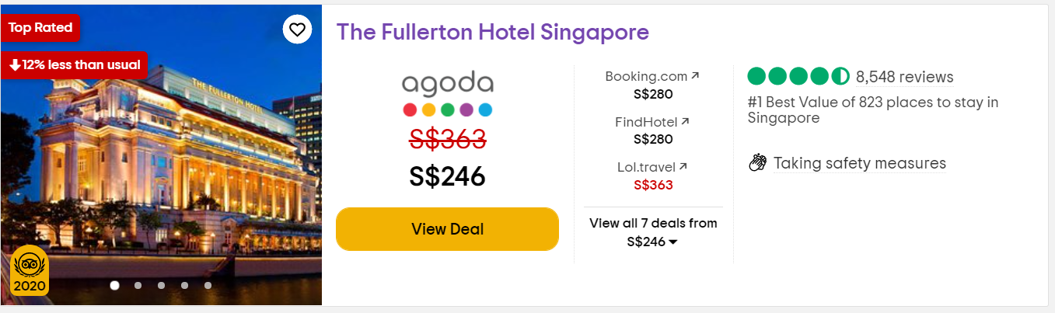

*Price on Trip Advisor^*

*https://www.tripadvisor.com.sg/Hotel_Review-g294265-d306173-Reviews-The_Fullerton_Hotel_Singapore-Singapore.html*

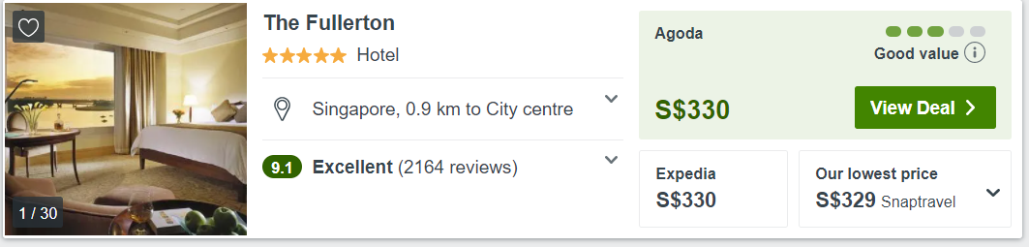

*Price on Trivago(link sends to Agoda)*

*https://www.agoda.com/en-sg/search?cid=1763324&currency=SGD&checkin=2021-03-08&checkout=2021-03-09&NumberofAdults=2&NumberofChildren=0&Rooms=1&mcid=3038&tchash=dL5wgNoxdr4&a2a=00&booking_source=1&trv_curr=SGD&trv_dp=330&trv_ttt=35&trv_tttb=29&trv_los=1&trv_losb=1&trv_pg=0&trv_defdate=1&tag=51b9d321-3022-4bb1-a1d2-f6347490a943&mobpf=0&hidef=001111&ccallout=1&selectedproperty=10589&city=4064&adults=2&children=0&hc=SGD&los=1*

* *Trip Advisor also has a better interface as the prices and information on the hotel will be loaded up on trip advisor so it would not need to open another tab to view the information on the Hotels*

*Shopping Malls (Jolene)*

* *There are quite a few websites like TripAdvisor like Expedia and Hotels.com. There are 171 malls in Singapore as of August 2020. I have also extracted 11,679 reviews taking the maximum possible reviews from each shopping mall with a minimum of 50 reviews on TripAdvisor. TripAdvisor is distinctive amongst all the different websites as they allow customers to leave a review for everyone to see. It allows tourists to see the likes and dislikes about a mall. Although, it is good that they have this factor, no one would actually read over a 1,000 reviews as the data is too much. The market segment are tourists who are looking for a destination to shop.*
* *For the competitive analysis, Shopping centre sales are still accounting for more than half of all retail sales across Singapore. As compared to other websites such as hotels.com whereby they give recommendations on the shopping malls, there aren't any reviews from customers shown. (have attached a picture below) It is mostly only writing on how good a shopping mall is without saying any bad things about it while on TripAdvisor the reviews are brutally honest which makes people interested in it. Hence, that is one factor why people would go to TripAdvisor to view the shopping malls as people would want to see both the good and bad side of a shopping mall.*

HOTELS.COM

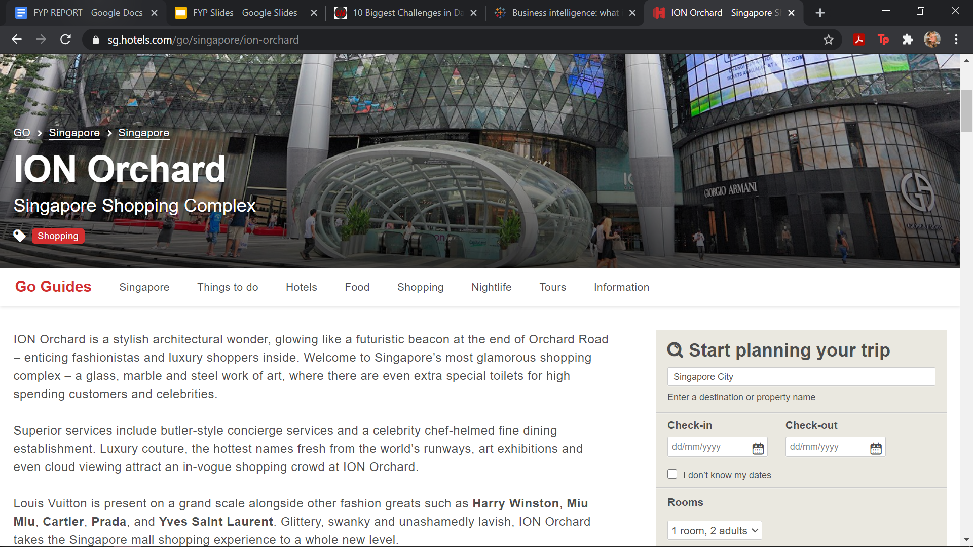

*TRIPADVISOR*

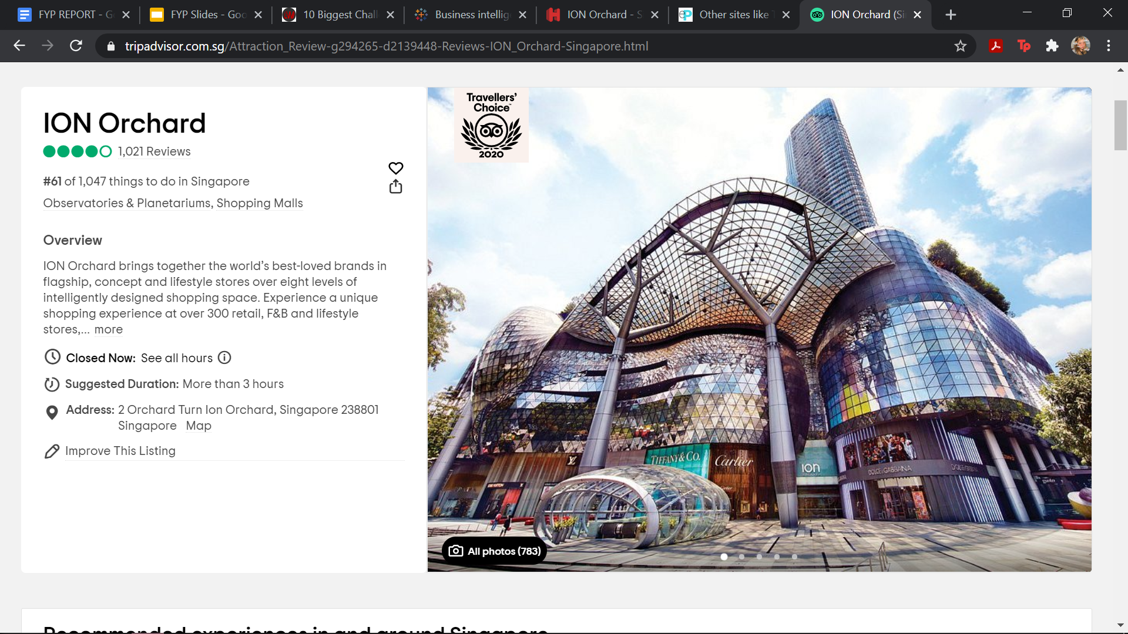

*Modes of Transport (Han Yew)*

* *The size of business is extremely big as for modes of transport as there are only that few companies for their transport category and the majority of the people have to utilise these modes of transport to get to where they want. The market segment of this topic would be mainly consumers who would be paying to be able to get to point A to point B without much of a hassle.*
* *For competitive analysis, not much can be discussed for SMRT and SBS as they are the main modes of transport in Singapore and realistically speaking, it is impossible for any competitor to be able to build a consumer base that SMRT and SBS currently have. However, the prices are extremely competitive between the private modes of transport, where they would want to secure as many customers as possible.*

*Attractions (Syukry)*

* *The size of the business solution is rather big as attractions play an important role in generating revenue for the companies in an oligopolistic market such as attractions in Singapore where there are not as many attractions as compared to malls and hotels.*
* *With regards to competitive analysis, multiple efforts by various attractions have been provided to increase customer satisfaction which will in turn bring about strongly positive reviews. Unfortunately, more visitors will also lead to more unsatisfied customers.*

## Business Solutions

***Section Explanation:*** *This subsection describes the business solution to the problem. Students are expected to demonstrate their ability in understanding the business logic and the process. Some important consideration is to understand the overall business process and not just the IT solution. The following may be included in this subsection*

* *Process flow*
* *How IT can help*

*Hotels (Tian Gan)*

* *Since there is a lack of people visiting the hotels in the category of Trip Type called “Travelled Solo” we could increase the number of this by having “Packages” with that we could have seasonal prices for a “Package” whereby we could include all the top rated places to go to when users are going on a solo trip.*
* *They could have more categories of Trip Type such as “Sight-seeing”, “Honeymoon” so that they could better create the Packages for the user for example if the user were to select Sight-seeing as a category of their trip type Trip Advisor could suggest a Hotel which is close to many popular sigh-seeing locations.*

*Shopping Malls (Jolene)*

* *The problem that I stated was that the reviews are too much raw datas for a tourist to look through and produce insights about it. Hence, the solution to this is in fact breaking down the raw data to get it processed and producing reliable visualization and predictive tables from it. The dashboards have to be clear and simple so that tourists can immediately get what is the point stated and find it useful instead of going through each and every review. Hence, IT plays an important role in doing this as researches have to be made beforehand for myself to understand the data and produce insights from it. Having this package on TripAdvisor would be beneficial as a tourist wouldn’t have to look through each and every shopping mall to find the best or worst.*

*Modes of Transport (Han Yew)*

* *The main problem is that when tourists come to visit Singapore, they would not be able to know which type of transport will cater to their needs and budget. Although there are websites which provide data such as user reviews and ratings, this might be too much for the average tourist to take in and to make a decision on their own. The solution to this problem is to simplify the data that the tourists can find easily on the sites. Tourists would want to visit a certain country but they might not be confident in selecting the transport mode that is most suitable for them, which is one of the most important choices as they would be totally foreign to the country and they will require a transport mode to get to where they want to go. This is where IT comes into play, where it provides the tourists a very easy to visualise set of data regarding the different modes of transport and this will eventually lead to the tourist selecting the mode of transport with ease as they data is extremely clear to understand. This will entice tourists to visit foreign countries as an important aspect, transportation, is already well-taken care of.*

*Syukry (Attractions)*

* *The main issue regarding attractions in Singapore is the quality of the experience that ranges from overpricing and overcrowding. There are multiple reviews that talk about how overpricing and overcrowding is an issue but there is no way for visitors to know where and when to avoid the attractions at the specific timings as it is not provided by the reviewer.*
* *The way IT can be used to overcome this problem is that it can be used to gather live or past data about the common visiting timing for visitors and the prices offered by the attractions. This way, visitors are able to witness the data or the data trends and can be notified as to which attractions they can visit or abstain from for the time being.*

# System Design and Implementation

***Section Explanation:*** *This section describes the architecture and the design of the system. It will briefly describe the various hardware and network interactions.*

*Business intelligence (BI) uses business analytics, data mining, visualization, tools and infrastructure and best practices to help companies to make more decisions that are dependent on data. BI can also help companies to make better decisions by showing present and past data within the business context. Analysts can also leverage BI to provide performance and competitor benchmarks to ensure that the company is able to run more efficiently. Analysts can also spot market trends easily to increase revenue. The right data can with anything from compliance to hiring efforts if used effectively. We did not use any hardware as we tabulated the data with Tableau software.*

## System Architecture

***Section Explanation:*** *This subsection describes the interaction between the different hardware. At the same time, it will describe the network topology that will be used by the system.*

Hardware will not be discussed as Tableau was utilised in this project. The network topology that will be used will be mesh topology. It is advantageous as there would be no data traffic issues as there is a dedicated link for the said devices. It is also reliable and robust as failure of one link would not affect another link to not work. This topology is secure as there is a point to point link and unauthorized access would not be allowed. Moreover, fault detection is easy which will make tweaking or improving the product easier.

## Detailed System Design

***Section Explanation:*** *This subsection includes the design documentation for the project. Care must be taken to ensure that the diagrams are clear and carefully organized.*

* *The following tools can be used to help in design:*
* *Entity Relationship Diagram*
* *Use Case Specification*
* *Unified Modelling Language Tools (e.g. Class Diagram, Sequence Diagram, only for OOP project)*
* *Data Flow Diagram*
* *Control Flow Chart*
* *Decision Table/Tree*
* *Pseudo Code*

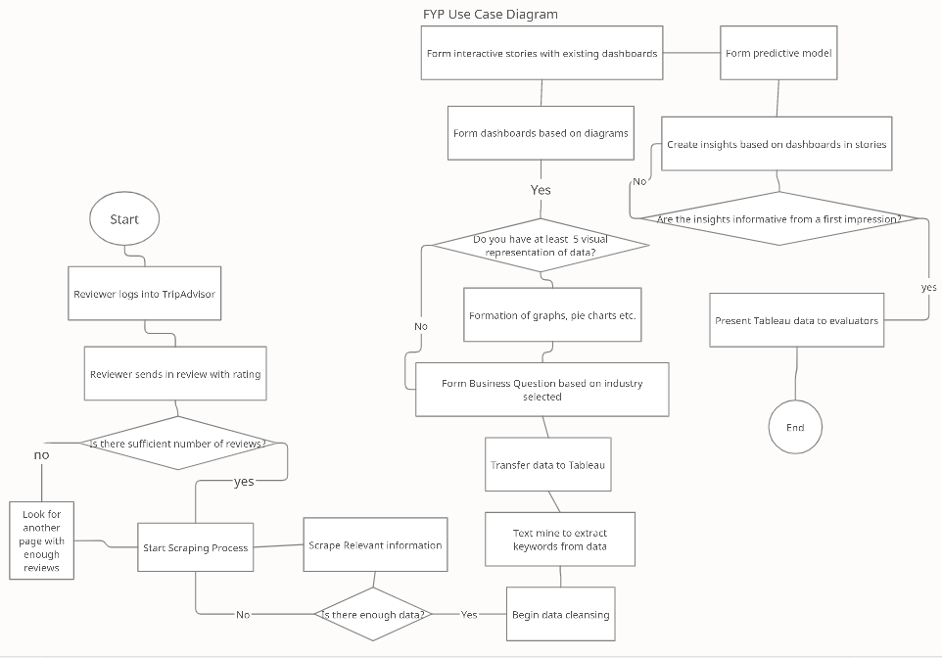

# System Testing

***Section Explanation:*** *This section describes how the system will be tested for robustness and fulfilment of functional and system requirements (Test Plan).*

*HOTELS (TIAN GAN)*

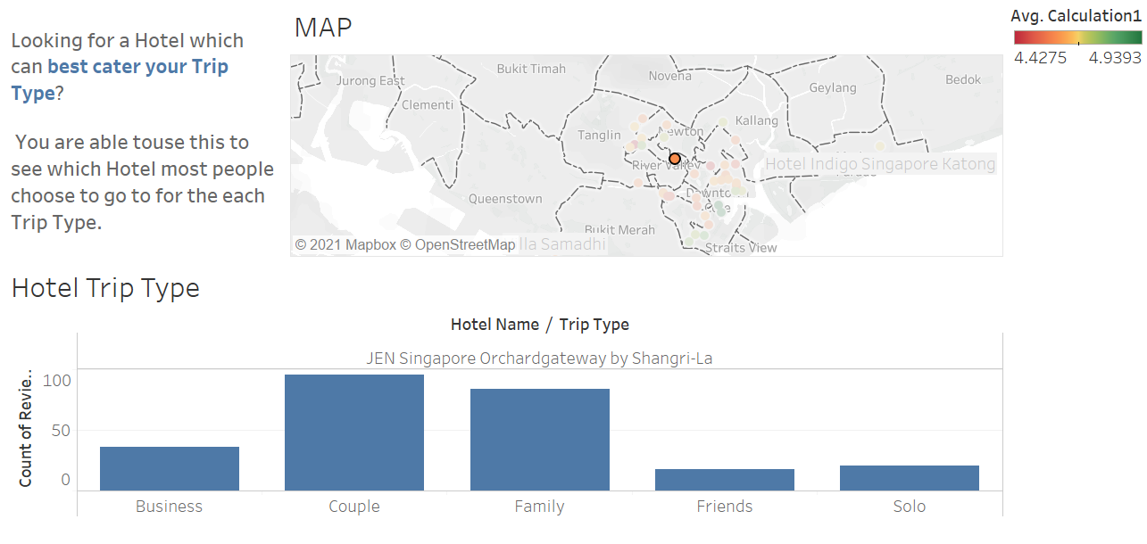

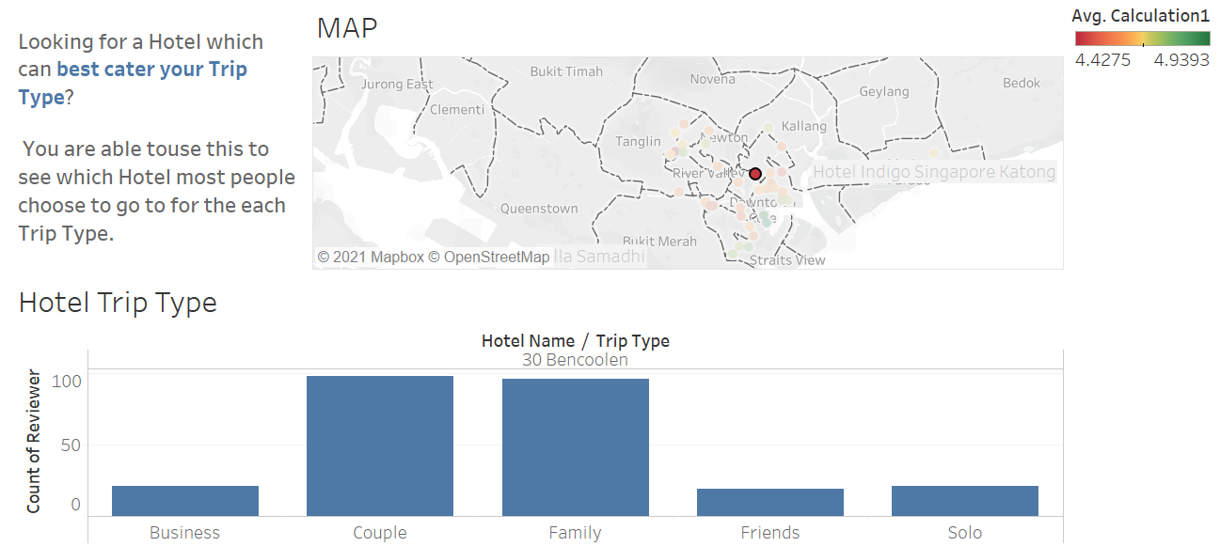

* *For this dashboard users will be able to click on the dots on the maps which shows the location of the hotels in a singapore map. After they have clicked on the dot on the map the graph at the bottom of the page will change and it will show the number of people that have visited the hotel and it is sorted into the various trip types.*

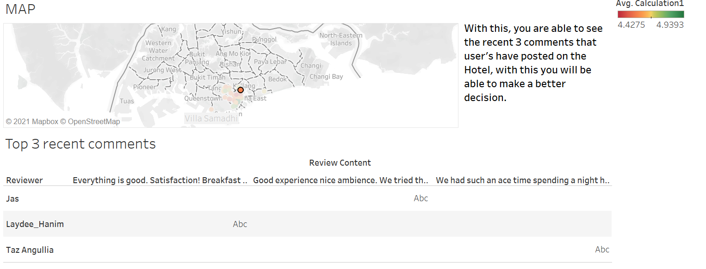

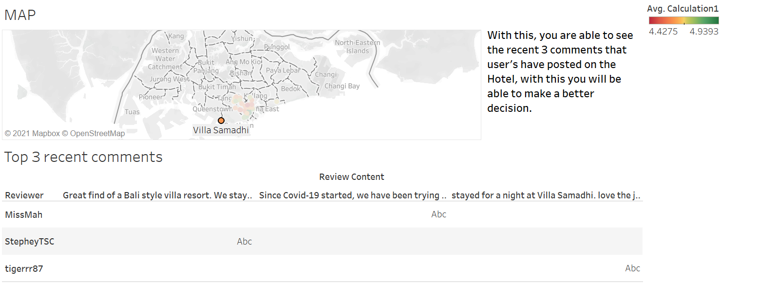

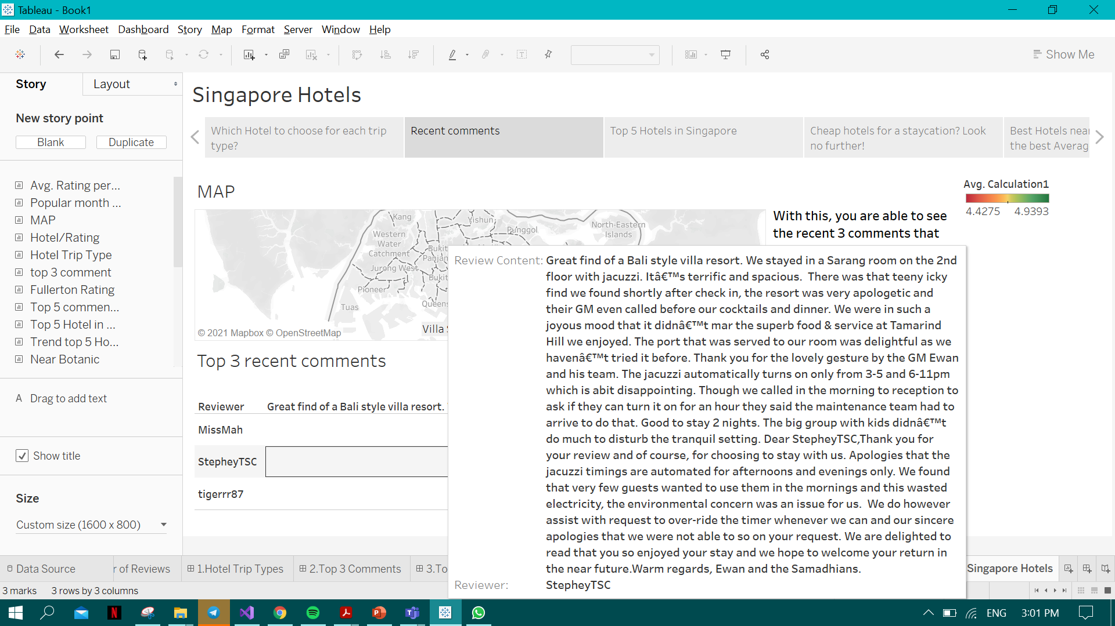

* *For this dashboard, users will be able to see the top 3 most recent comments of the hotel. The user will be also clicking on the dots on the map and after clicking on the hotel that they would like they will be able to to hover on the “Abc” and be able to see the comment.*

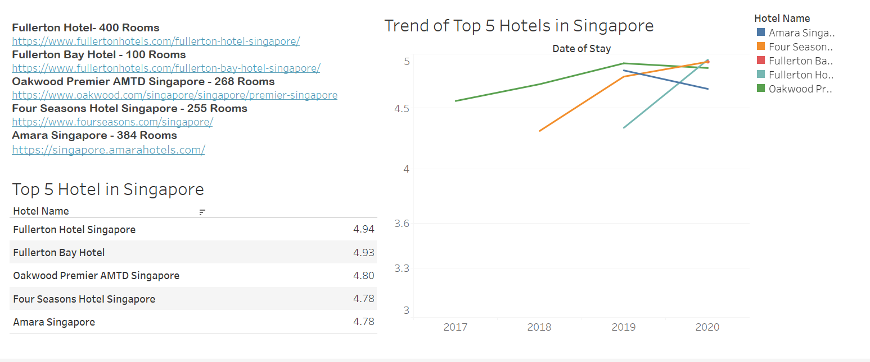

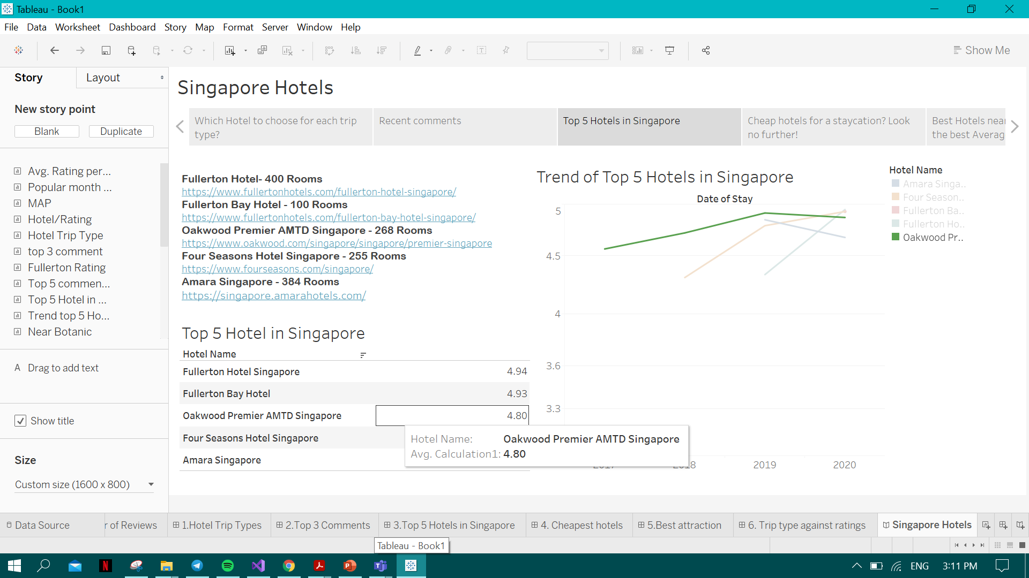

* *For this dashboard it shows the top 5 average rated hotels and if the user was to hover their mouse over the Hotel name the line graph which belongs to the hotel will be highlighted as shown above*

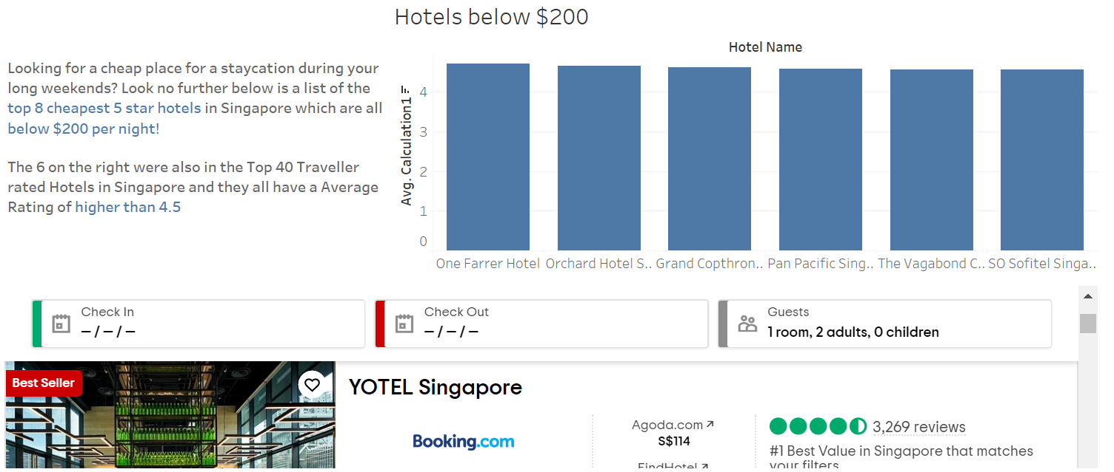

* *For this dashboard it will show a list of the cheap hotels which are below $200 per night. The graph on the right side shows the 6 hotels which are below $200 per night and they are alos within the top-40 Traveller rated Hotels in Singapore.*

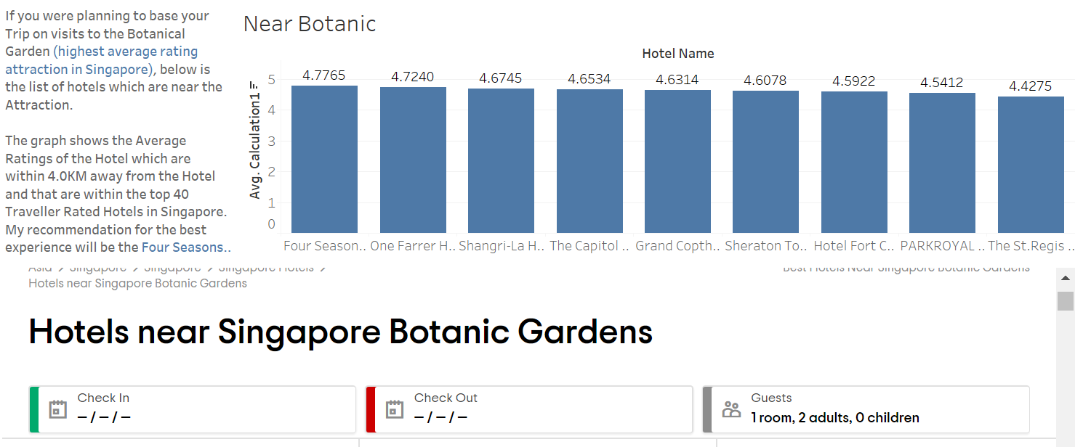

* *This dashboard shows the hotels which are near the Singapore Botanic Gardens. The graph on the left shows in descending order(rating) of the hotel rating, the graph only contains the top 40 traveller rated hotels in singapore and which are within 2km away from Botanic Gardens.*

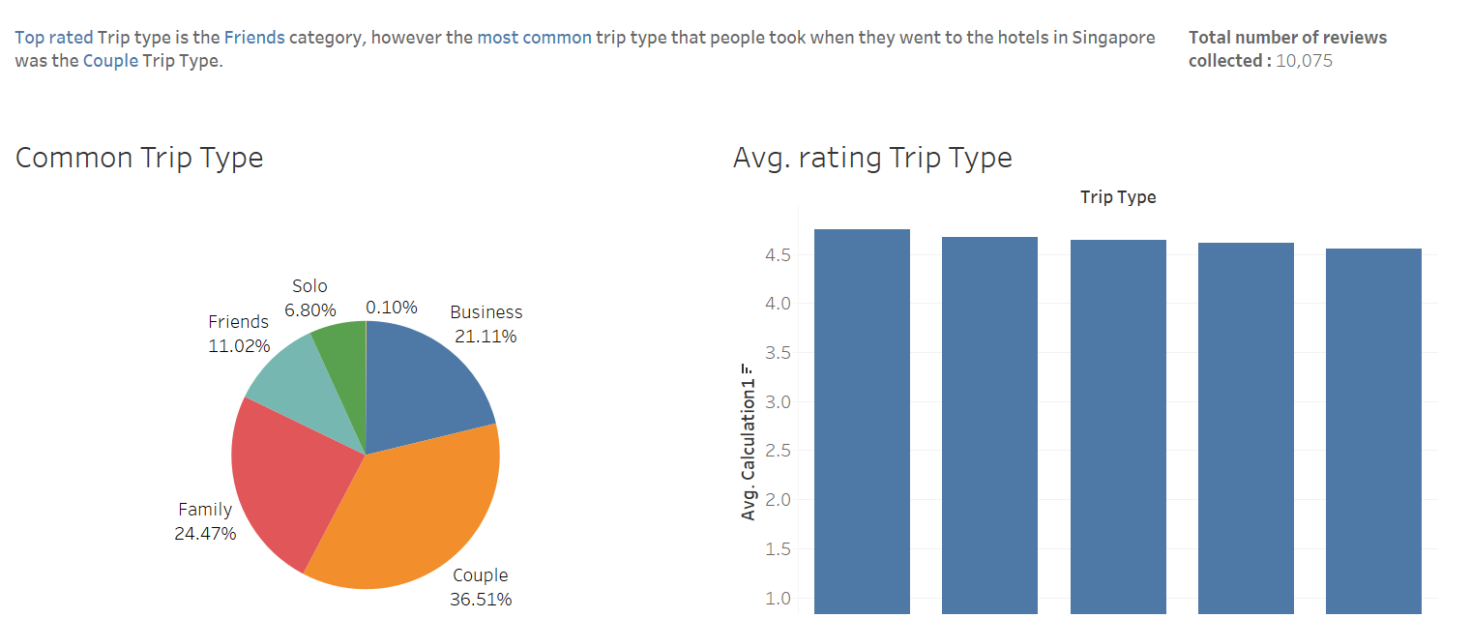

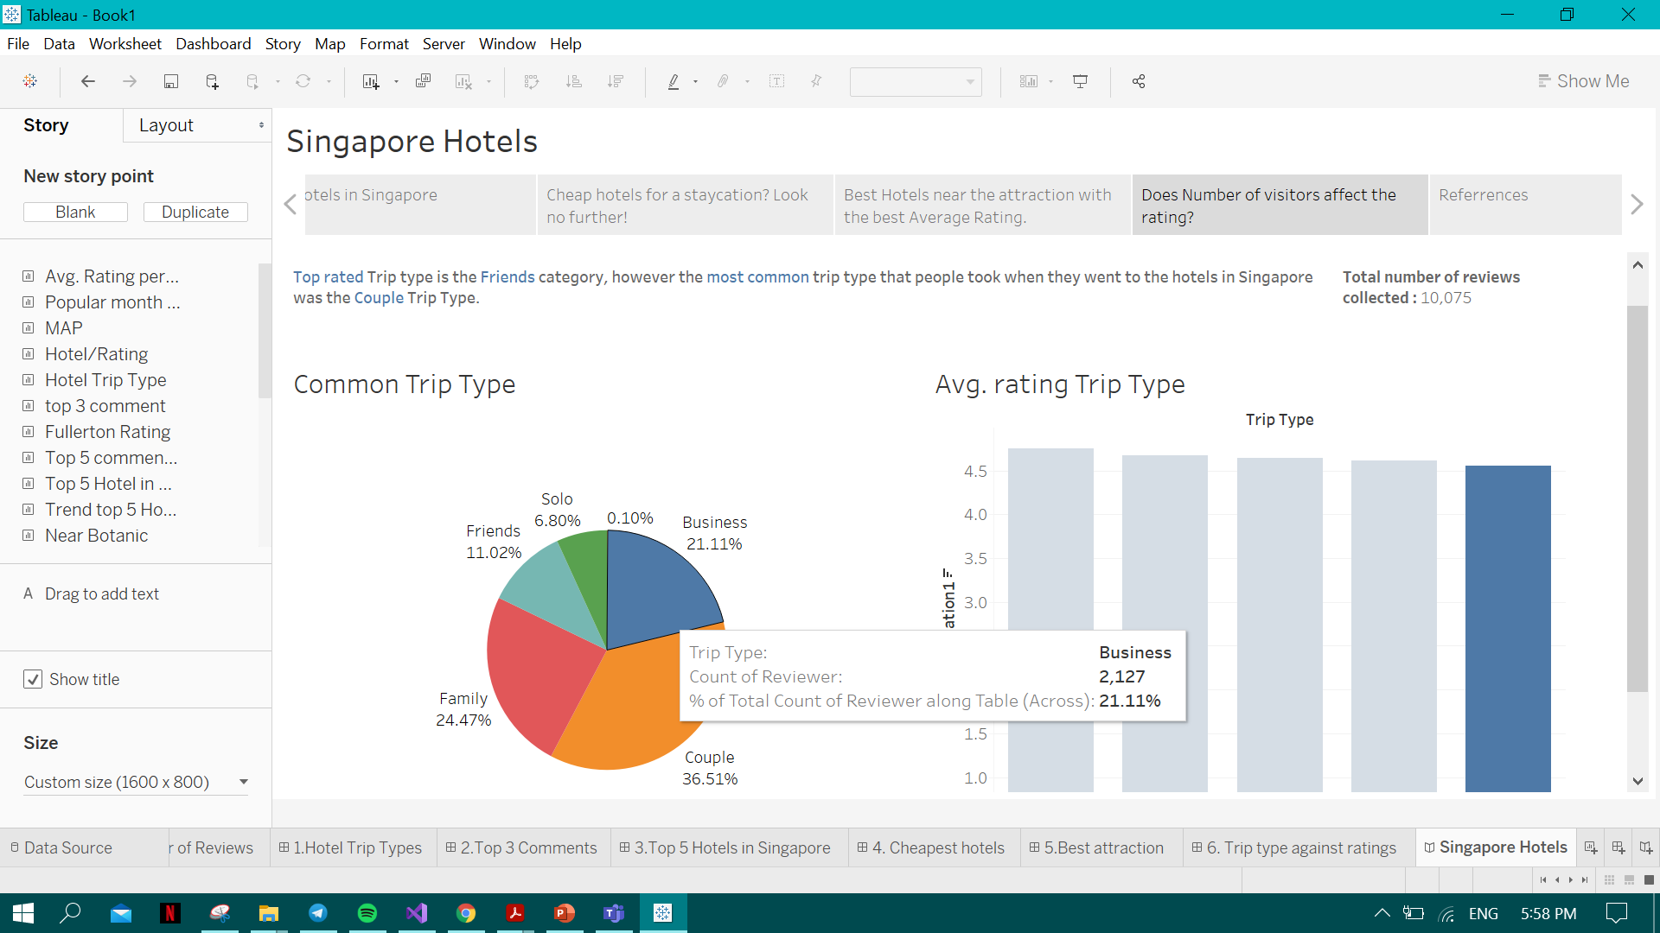

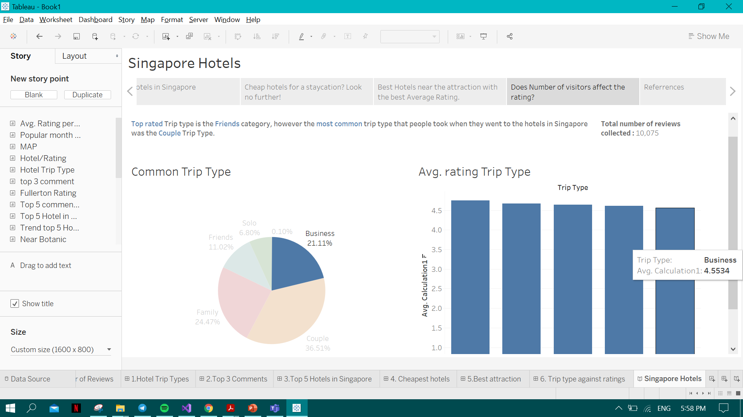

* *For this dashboard when the user hovers over a part on the pie chart the same trip type will be highlighted on the bar chart for example if you were to hover over the business trip type on the pie chart the business trip type on the bar chart will be highlighted and vice versa.*

*SHOPPING MALLS (JOLENE)*

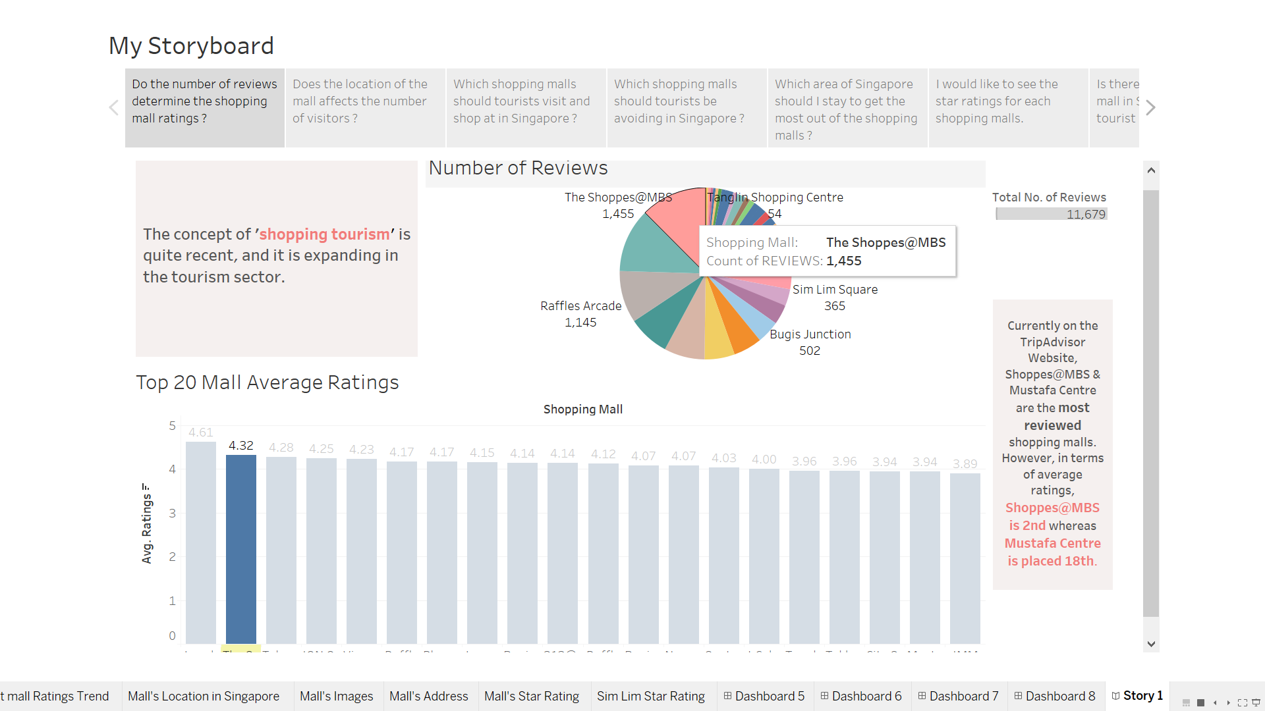

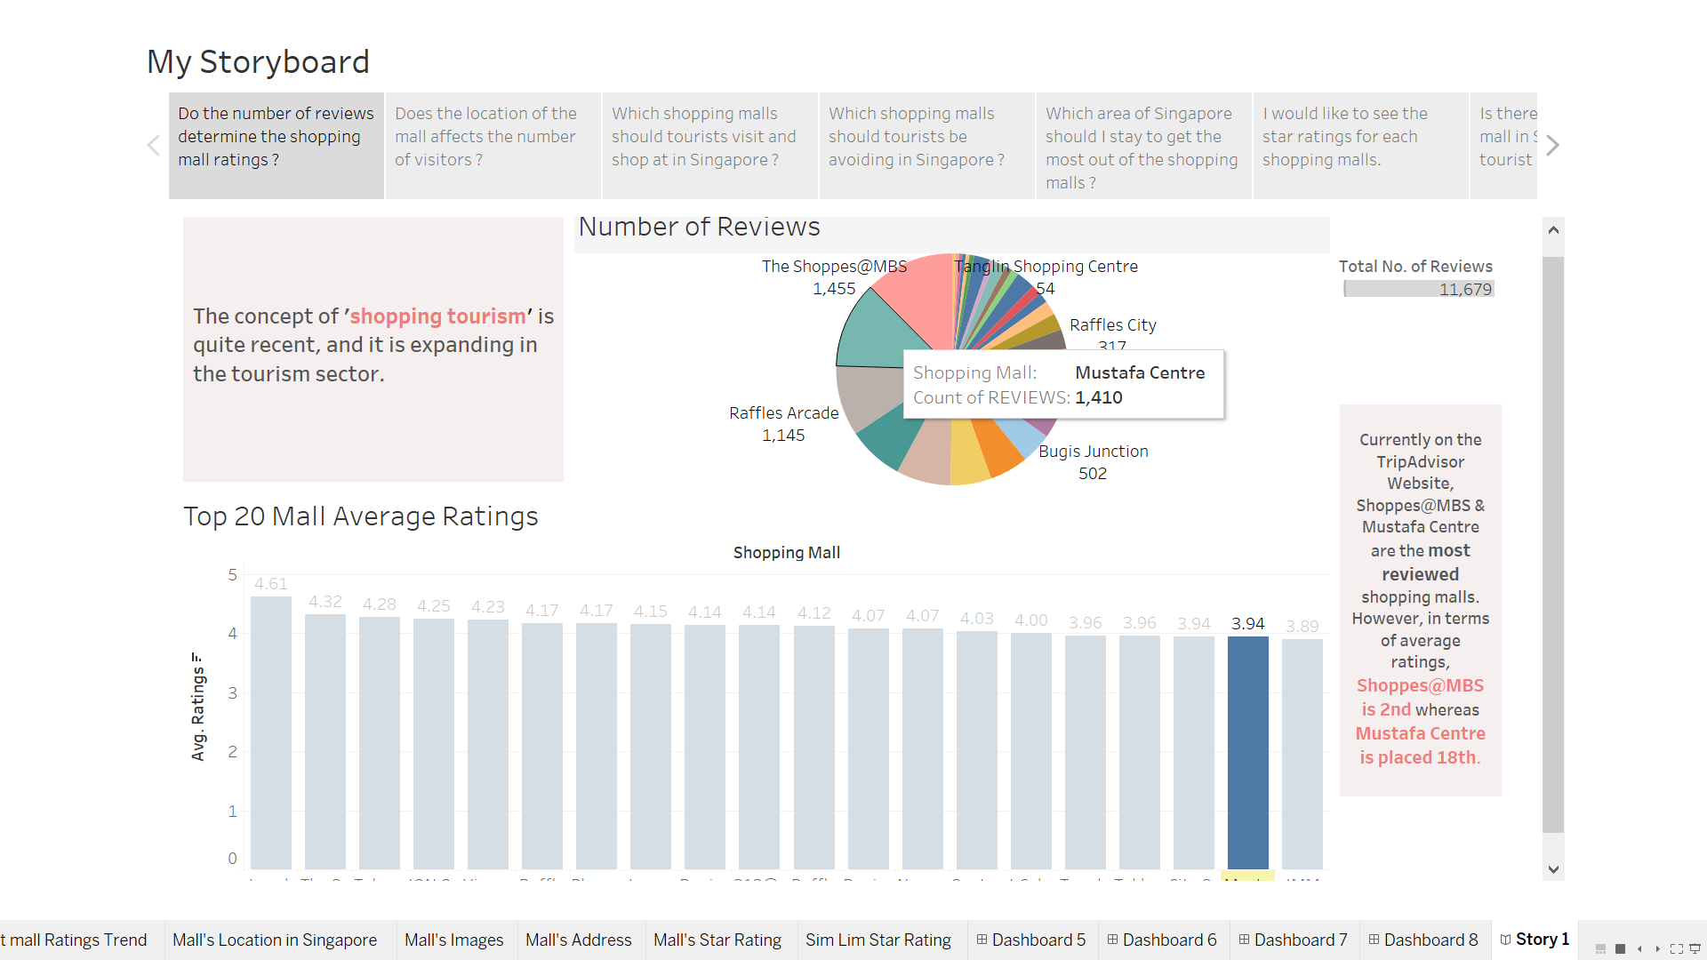

* *These 2 stories above are to prove to tourists that the higher the number of reviews doesn’t mean that the shopping mall is better than the others. As shown, I have added an action in the dashboard whereby the bar of the shopping will get highlighted when it is hovered over from the pie chart. As shown, the 2 shopping mall with the highest number of reviews on TripAdvisor have drastic rankings based on the average ratings.*

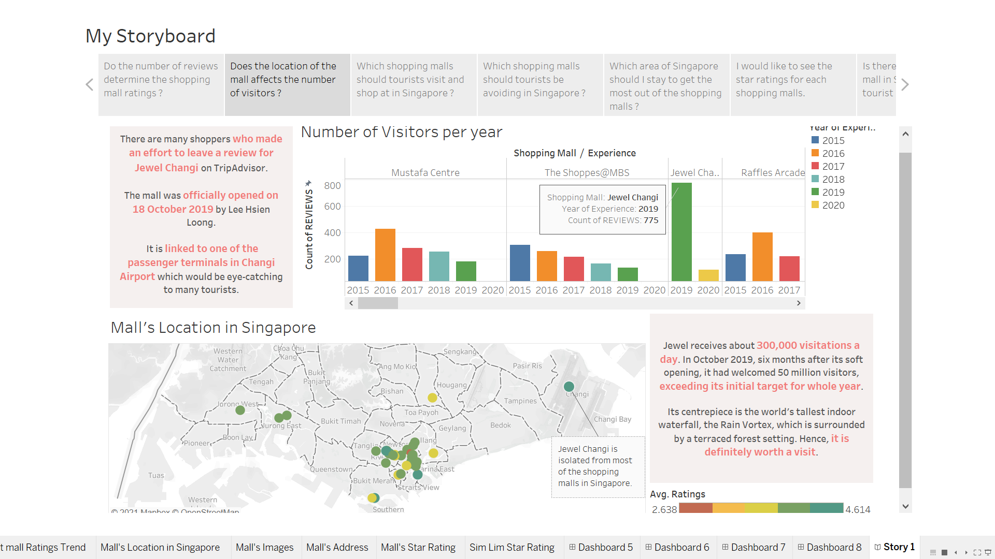

* *This story is to prove that although Jewel Changi is not located in central where most of the shopping malls are, its count of reviews is so much more when compared to the others. The difference is fairly obvious when the mouse is dragged across the bar charts to observe. Hence, tourists should drop a visit if they were to visit Singapore.*

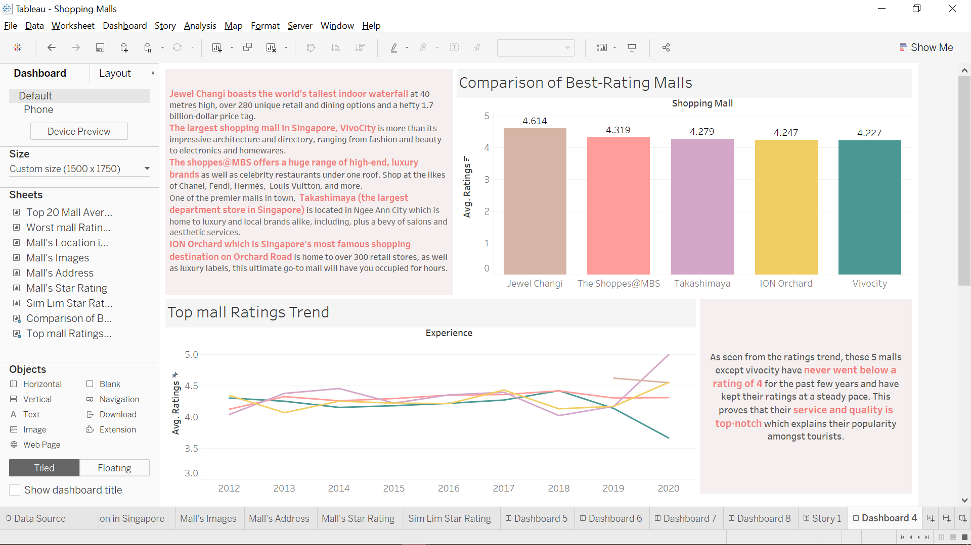

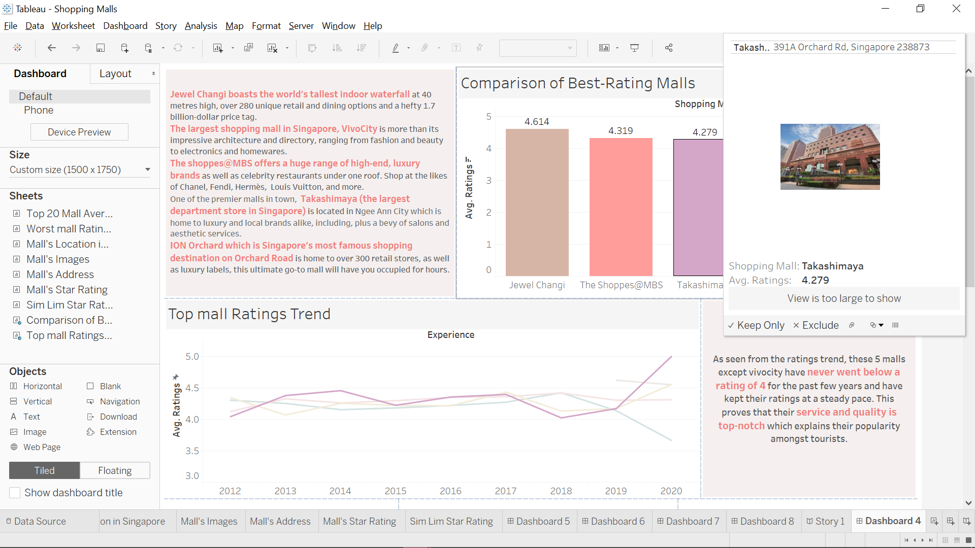

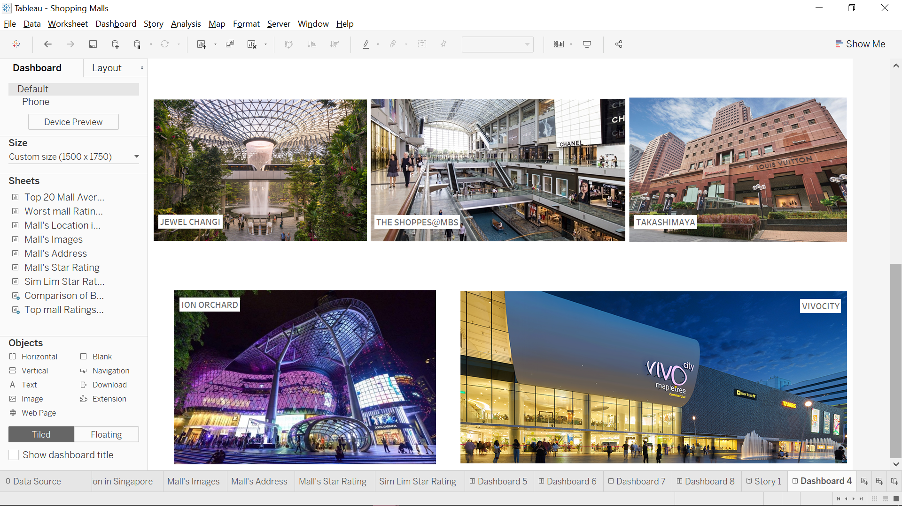

* *These 3 stories are to show tourists the top 5 shopping malls in Singapore in terms of their average ratings. The main attractions of each mall have been stated briefly in the text box. As shown, the trend of their ratings have always been very stable which proves their standard of a shopping mall. I added a user interface whereby when the user mouse briefly on the bar chart of each mall, the mall’s address and photo will be shown. When scrolled down from the story, the pictures are there for easier viewing of each shopping mall. The trend line would also be highlighted for easier viewing when hovering over the bar chart.*

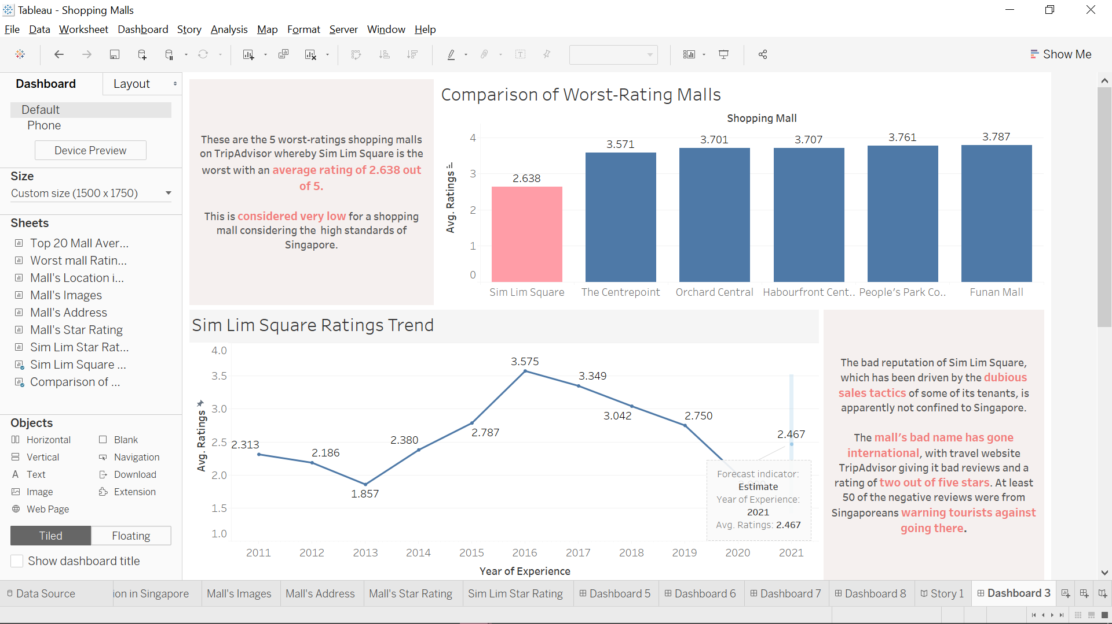

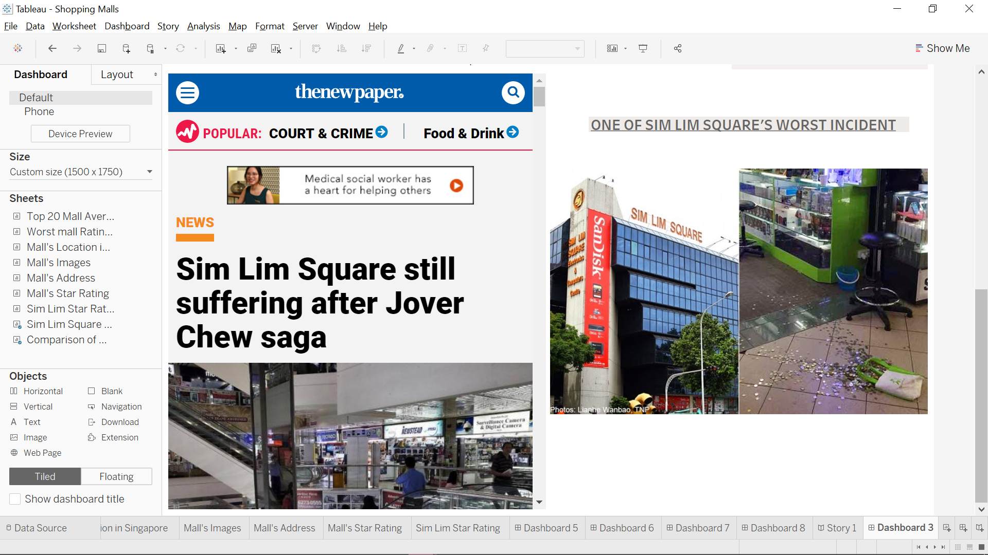

* *Since I have shown what shopping malls tourists have visited if they come to Singapore, this is the few that they should avoid at all costs.Based on the worst 5 average ratings, Sim Lim Square is the most distinct one and when scrolled down from the story, news articles have been provided to understand why their reputation have always been bad. I also did forecasting on its average ratings trend line to see if they would be able to rise from the bottom. The mall's address and photos have also been provided in the tooltip for further knowledge.*

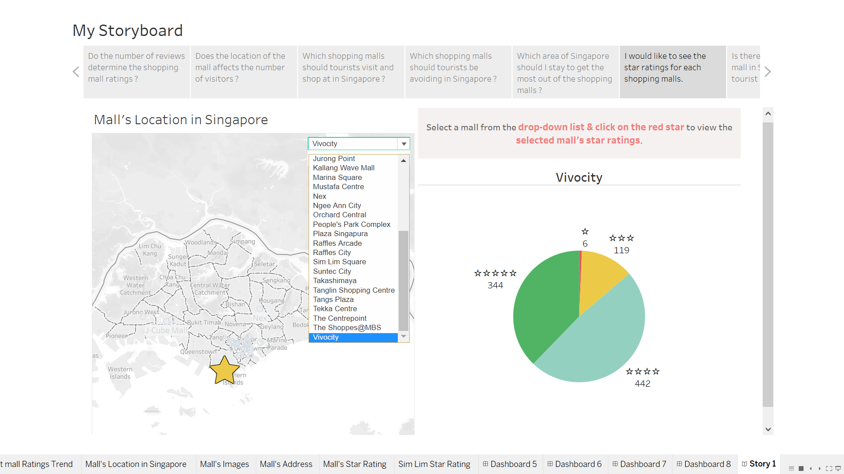

* *For this story above, I have added an extension from Tableau which enables me to select from a drop-down list. Once a mall is selected, the mall will be starred in the map as shown. To see the number of star ratings they have, the user has to click on the yellow star on the map. To produce this kind of pie chart, I actually have to do a little coding and research since the symbols have to be added as well. This story will enable the tourists to view the number of star ratings of TripAdvisor instead of raw data.*

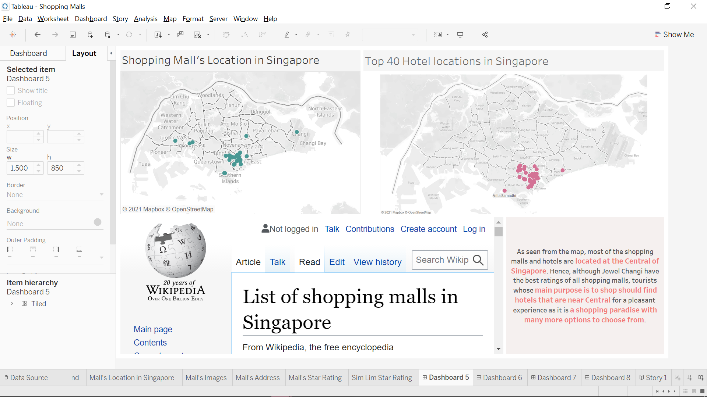

* *This story above is to suggest tourists on where they should stay if they were to visit Singapore with the main purpose of shopping. I have cross-domain with hotels on its location and the top 40 hotels are also located in the Central area. The wikipedia link is to give a full list of the shopping malls located in Central for tourist’s knowledge.*

*TRANSPORTATION (Han Yew)*

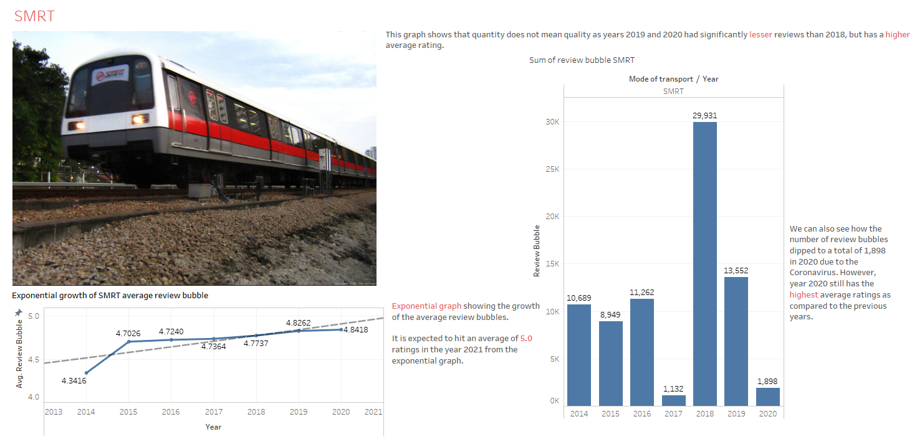

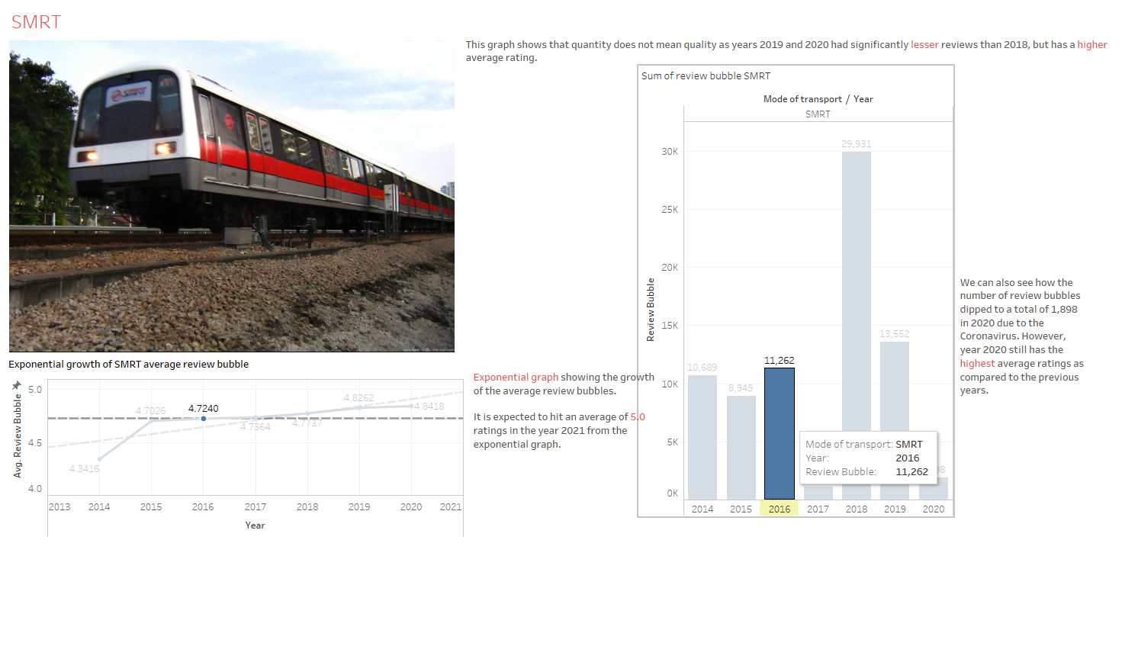

*This dashboard shows the exponential growth of the average rating bubble and SMRT’s total review bubble from year 2014 - 2020. Hovering over a certain year will highlight the respective year in the line graph and in the bar chart.*

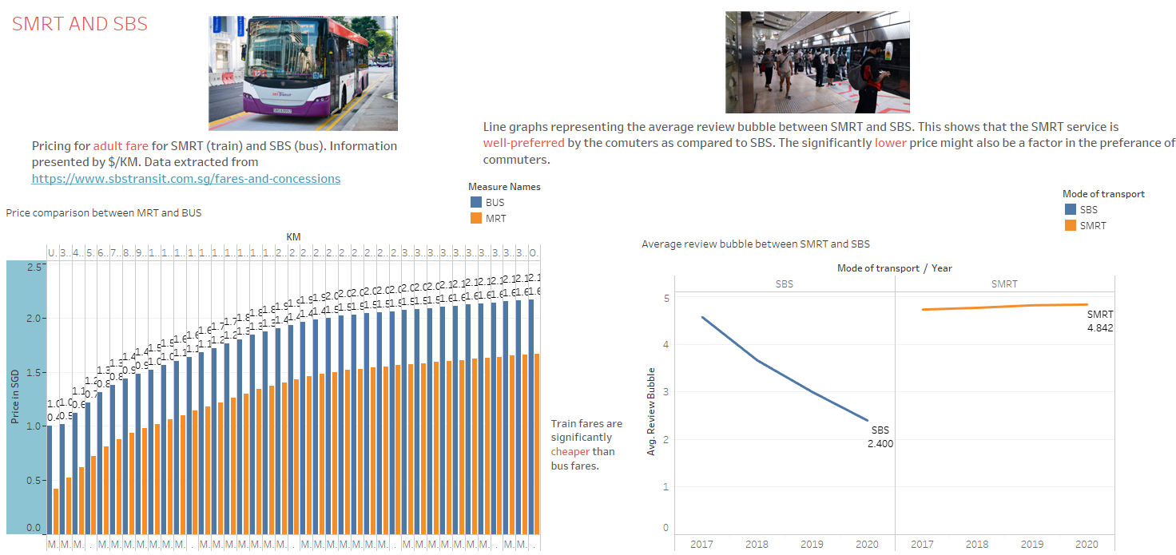

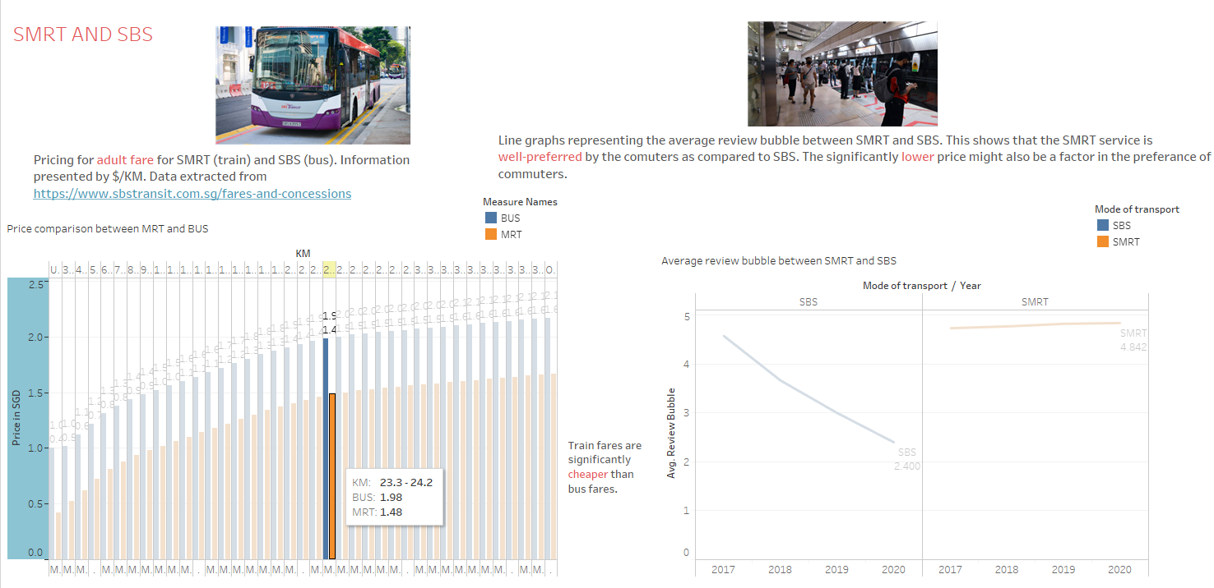

*This dashboard shows the price comparison between SMRT and SBS. There is also a line graph present showing the average rating bubble between the two from year 2017 - 2020. Hovering over a price will highlight the KM in the bar graph. Hovering over the line graph will highlight the year that is chosen.*

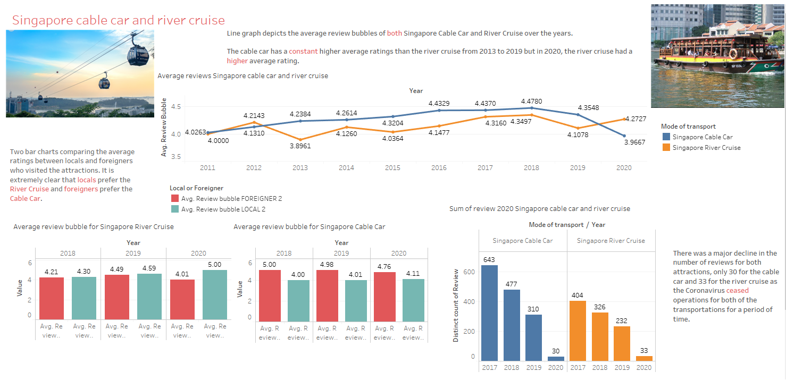

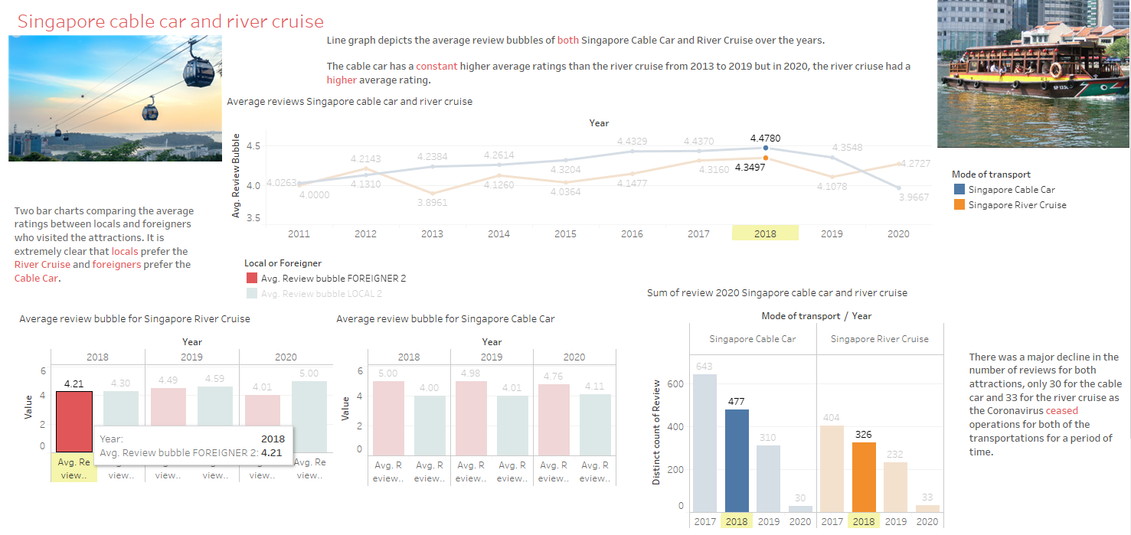

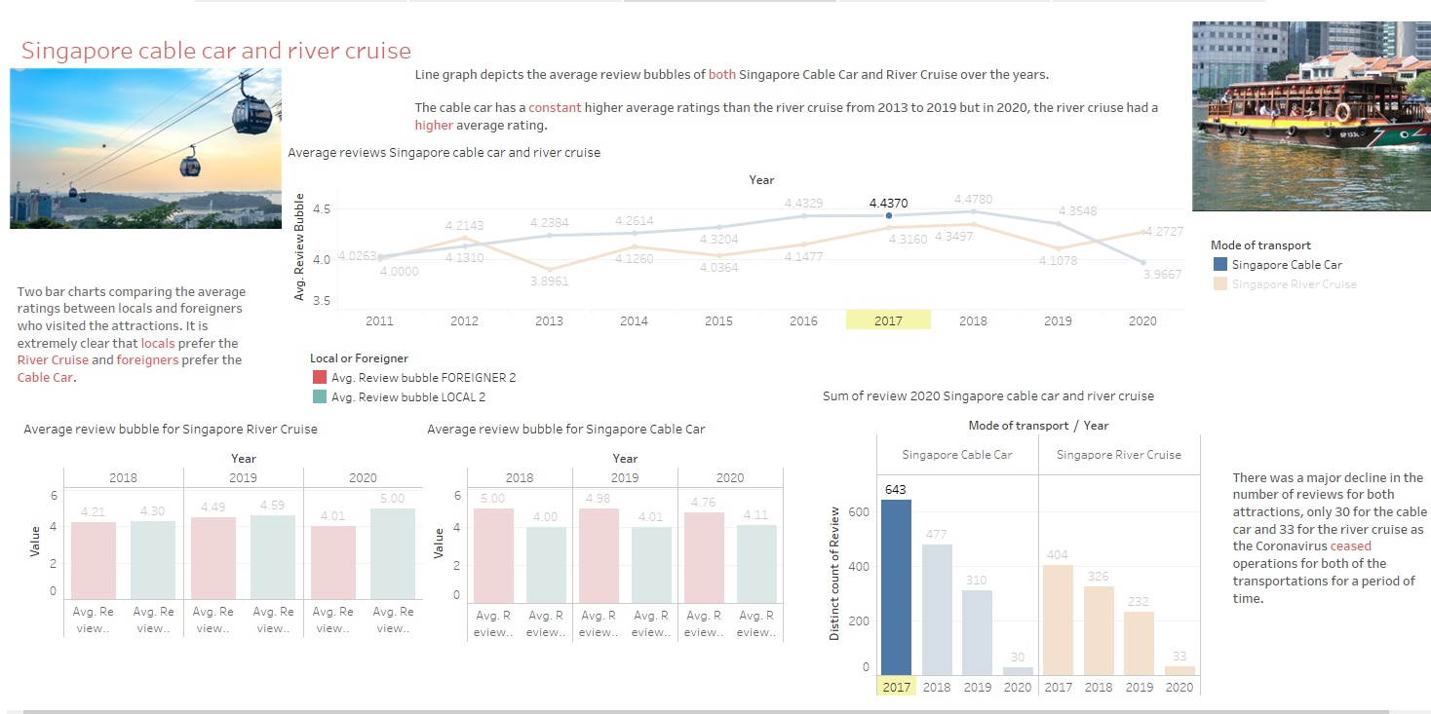

*This dashboard shows the comparison between Singapore Cable Car and River Cruise. The line graph shows the average reviews from the year 2011 - 2020. The graph on the left shows the average ratings given by locals and foreigners who visit the attraction. The graph on the right shows the total reviews of both attractions from the year 2017 - 2020. Hovering over a certain attribute will only show the relevant attributes.*

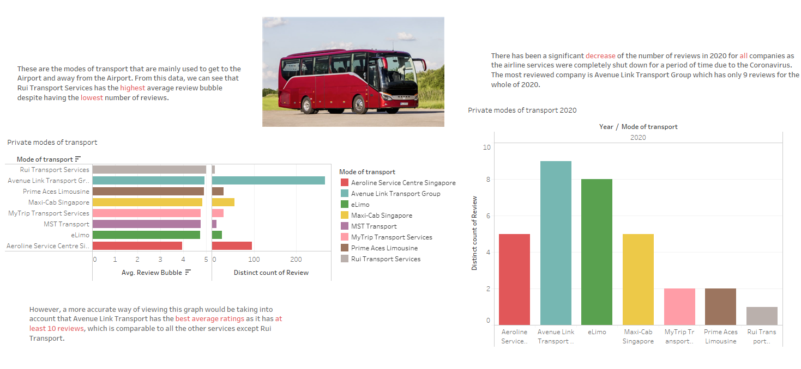

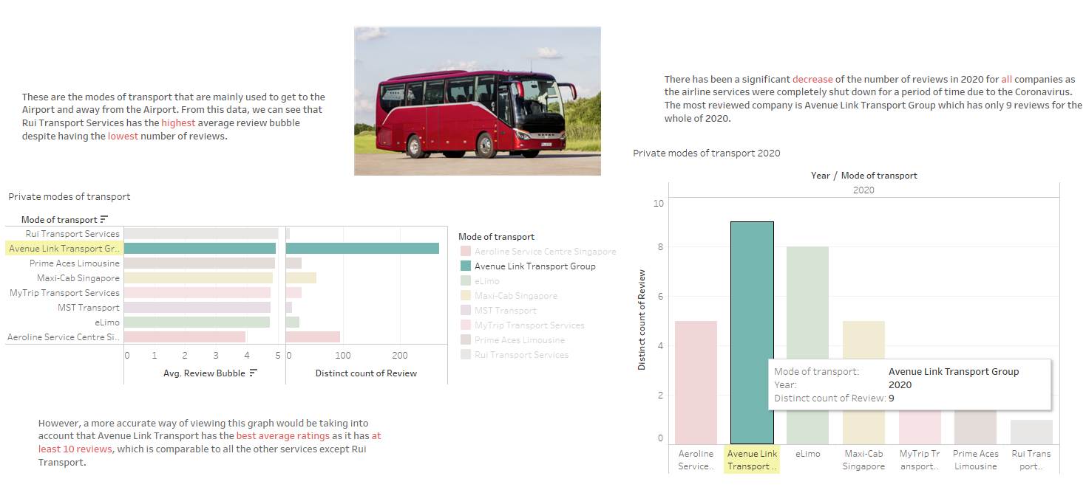

*This dashboard shows the comparison between 8 private modes of transport. The graph on the left shows the average review bubble with the total reviews of each mode of transport. The graph on the right shows the declining reviews in total in the year 2020. Hovering over an attribute will highlight the specific travel group.*

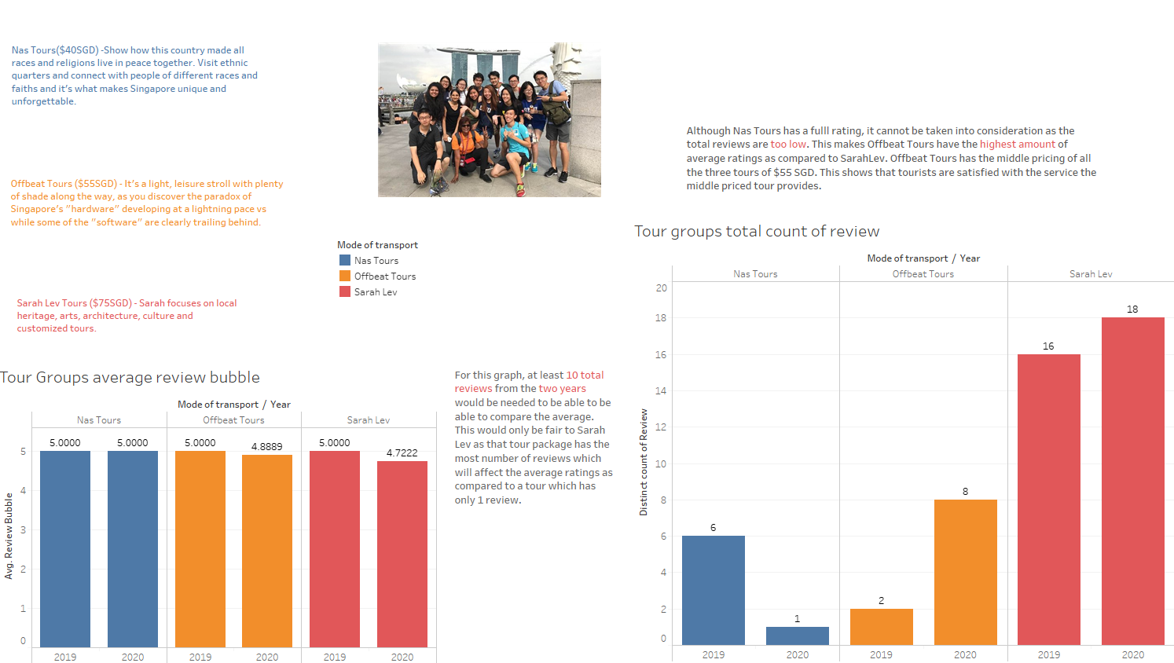

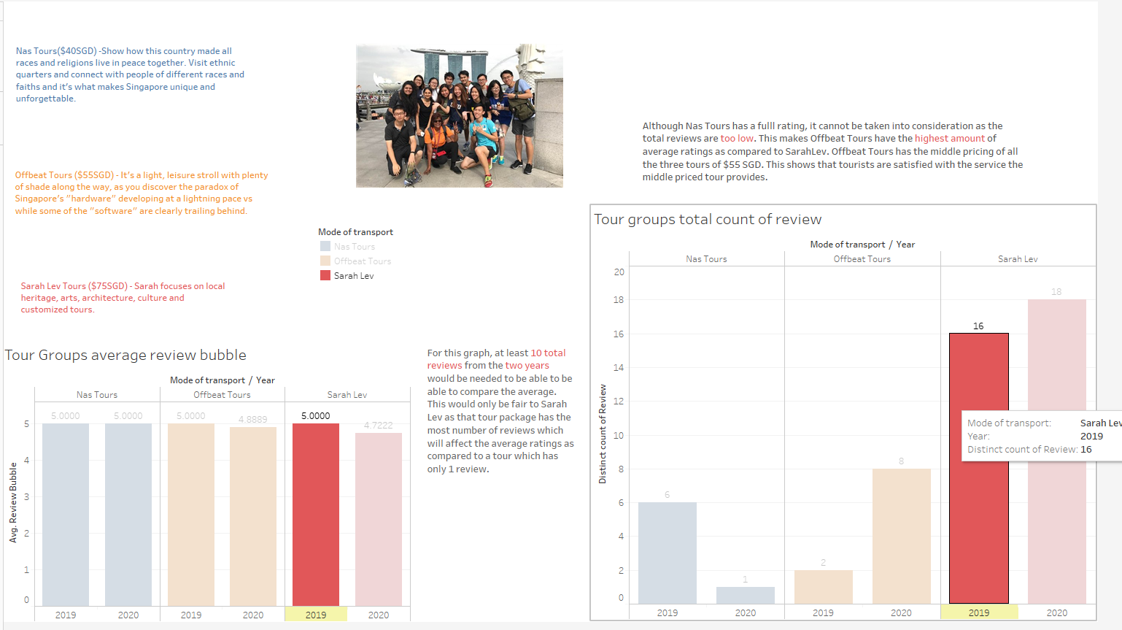

*This dashboard shows the comparison between three different tour groups, with the description of what they do and the different price points that they offer. The graph on the left shows the average ratings for each tour between 2019 to 2020 and the graph on the right shows the total number of reviews. Hovering would highlight the specific tour.*

*ATTRACTIONS (SYUKRY)*

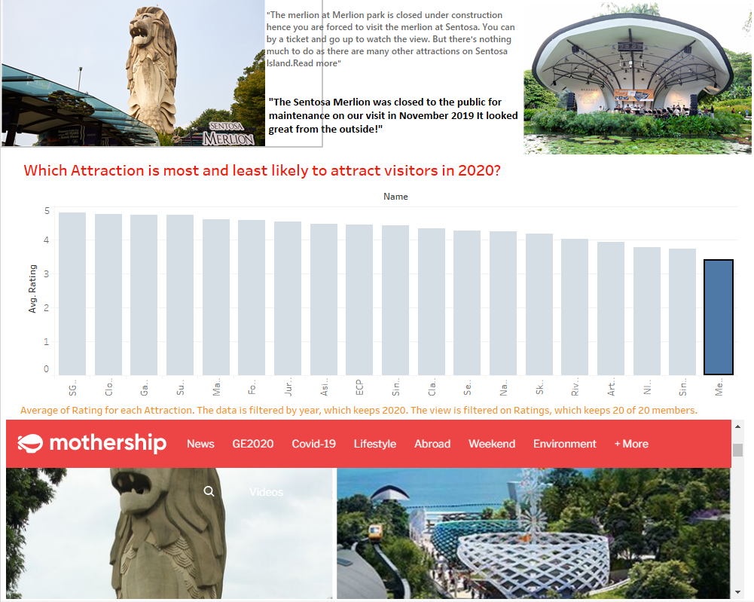

This dashboard talks about the least popular attraction in Singapore and the reason behind it being the least average rated.

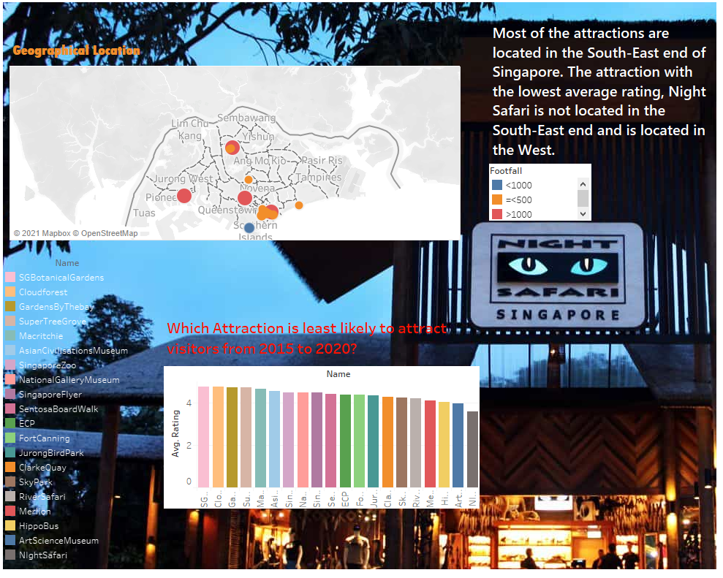

This dashboard is regarding the geographical location and footfall for the respective attractions.When hovered on the map, it will indicate the average rating of the attractions from 2015-2020.

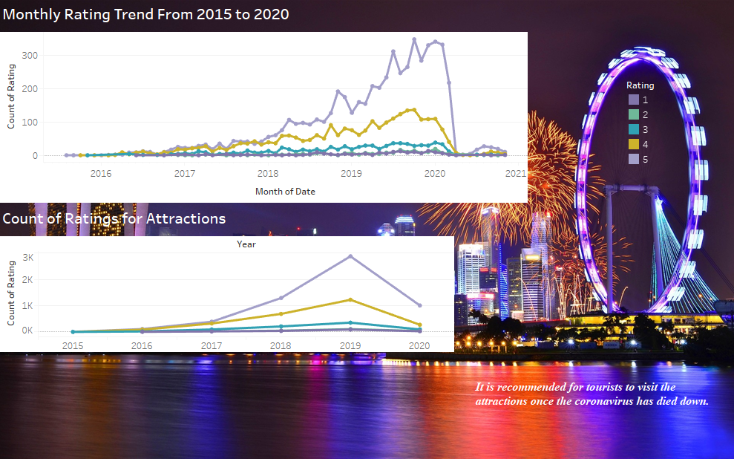

*This dashboard indicates the trend of the count of ratings from the years 2016-2021.*

*The graph has been downsized for easier reference for the viewer.*

*These graphs indicate the impact that COVID-19 has made on Singapore tourism and how the number of visitors have significantly reduced.When hovering over the trend lines, it will be highlighted on the other graph for a simpler comparison.*

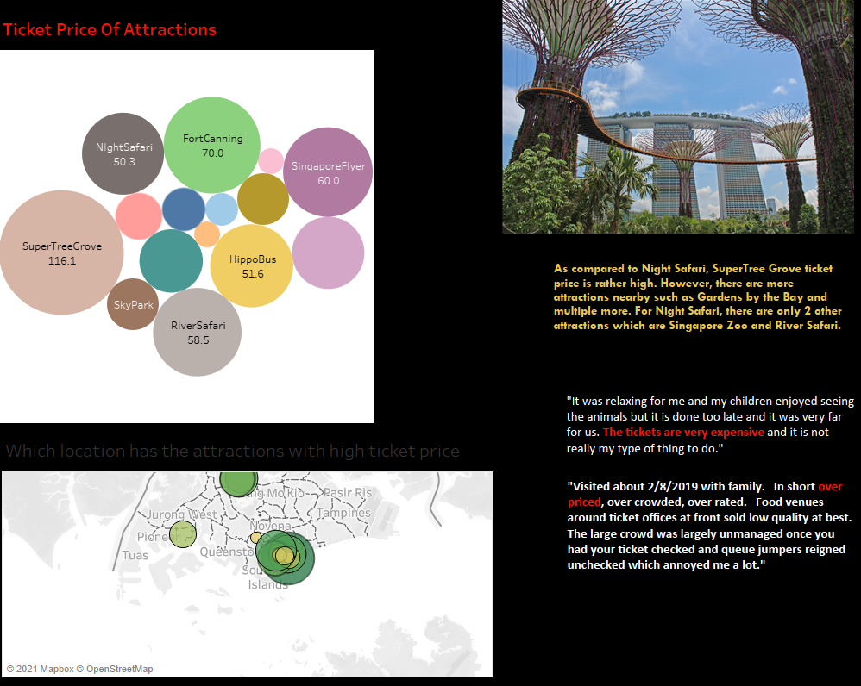

*This dashboard indicates the ticket prices of the attractions on the map and discusses the reviews that visitors have provided regarding NIGHT SAFARI that is quite far from the other attractions clustered in the central area. When hovering over the ticket prices on the map, it is highlighted by the circle diagram that represents the price of their ticket prices.*

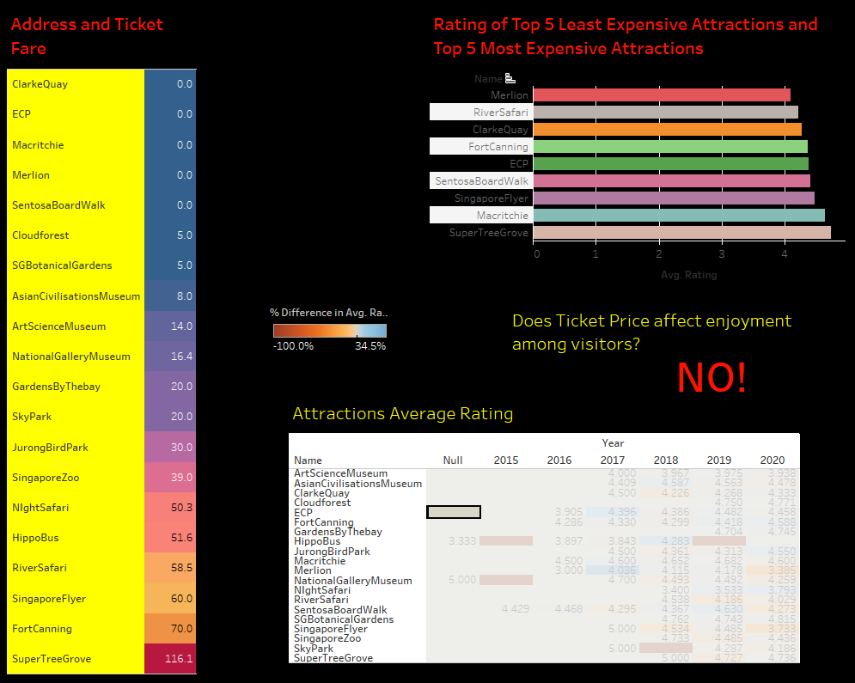

*This dashboard discusses the top 5 expensive attractions and top 5 least expensive attractions. Along with this is a heated table that shows the difference in rating between the years.*

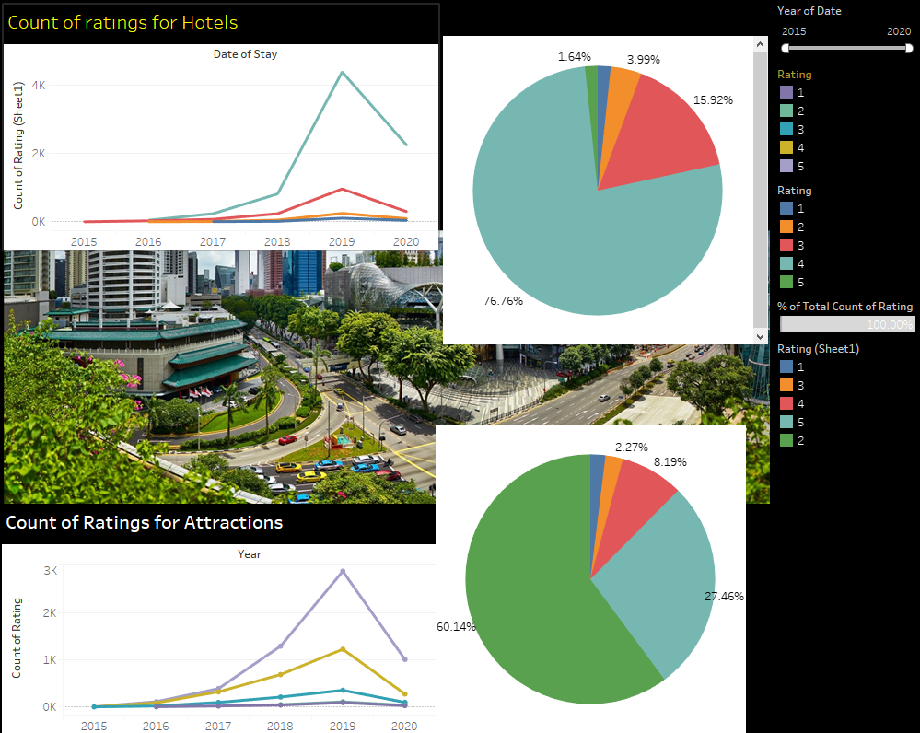

*This dashboard compares the count of ratings for attractions and hotels from 2015 to 2020. When hovering over the lines, it will be highlighted on the pie charts.*

# User and Technical Documentations

## User Documentation/Guide/Manual

***Section Explanation:*** *A user documentation or manual should be produced to describe how the system should be used. It should be readable and understandable by a non-technical person (i.e. someone who is IT illiterate). Illustrations and graphics can be used to great advantage here.*

*Data Scraping Demo*

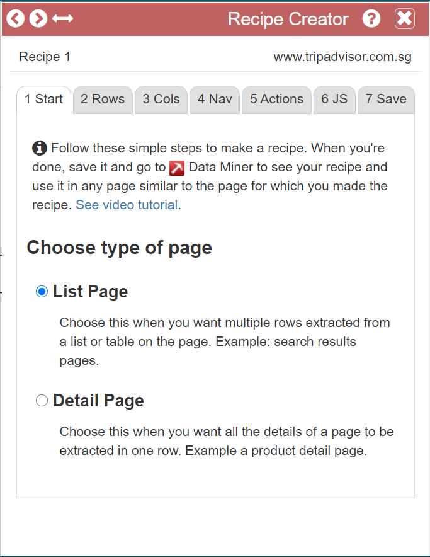

*First you will need to create a recipe.*

*Then you will need to choose the type of page that you are scrapping.*

*Since the Reviews are a List Page we will go ahead and select that.*

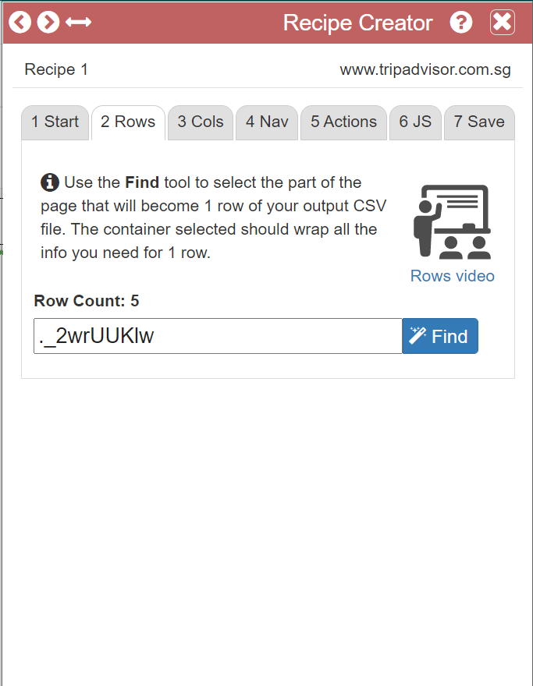

Next select the rows of data that you will like to scrape by clicking on Find then hover over the row that you will like to scrape and press SHIFT.

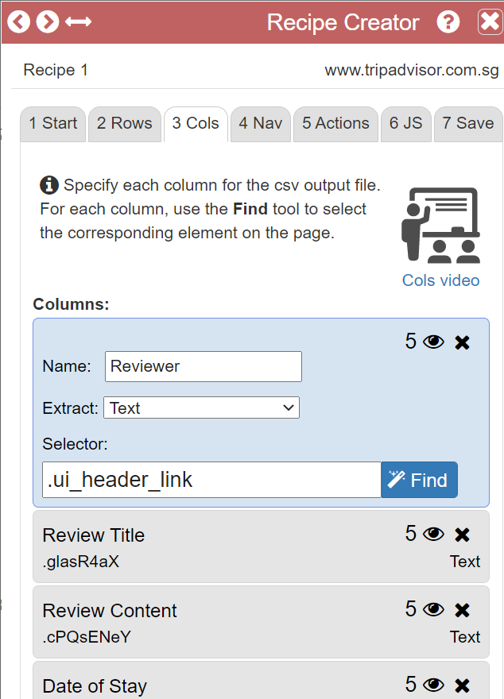

After that you will need to select the columns that contains the data you want in the file.

For Reviewer, Review title and Review Content we have tasked the program to extract the text since that is what we need from those columns

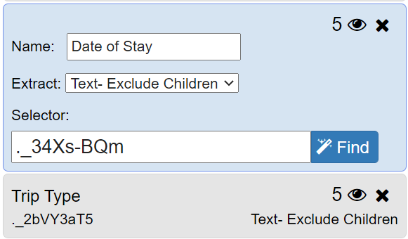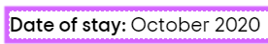

For Date of Stay and Trip Type we have selected the “Text - Exclude Children” as it will then not include the header like “Date of Stay” and it will just take in “October 2020”

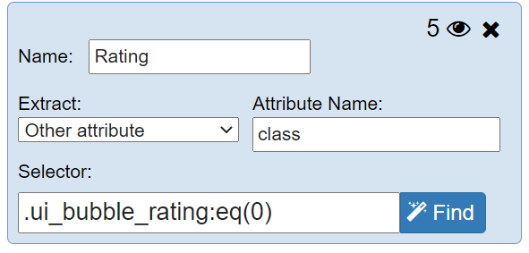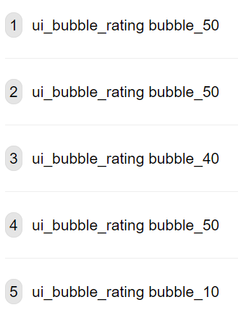

For Rating column we will need to select the “Other Attribute” and in the attribute name type “class” this will tell the program to extract the class from the line of code which is “ui_bubble_rating”

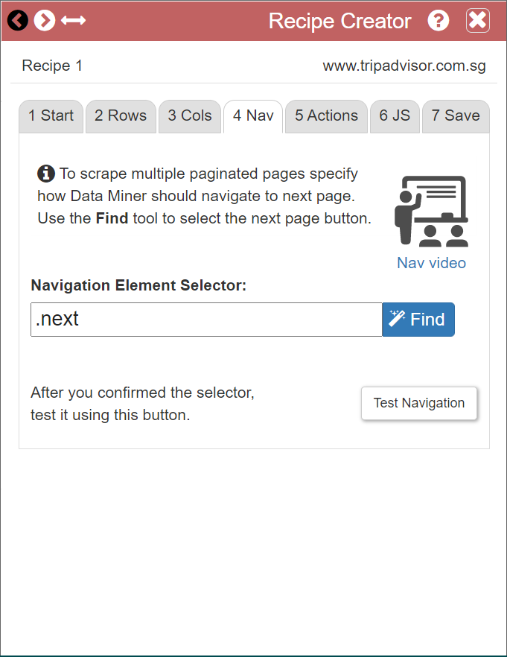

The next step is to tell the program how it is to get onto the next page, to do so we will need to click “Find” and hover over the next button and press SHIFT.

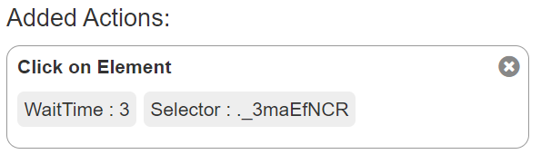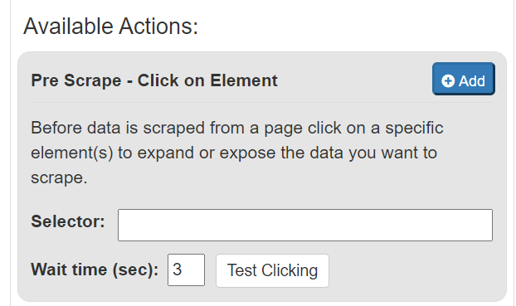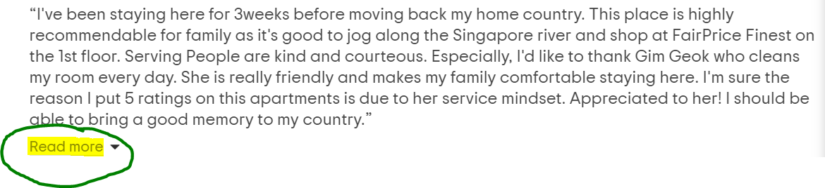

After the pagination is done, we will need the program to click a “READ MORE” button to get the “Date of Stay”, etc.

To do so we will need to get the selector and paste it into the click on element box then click on add

After that name your recipe and then save it so you are able to use it on another page on the same website

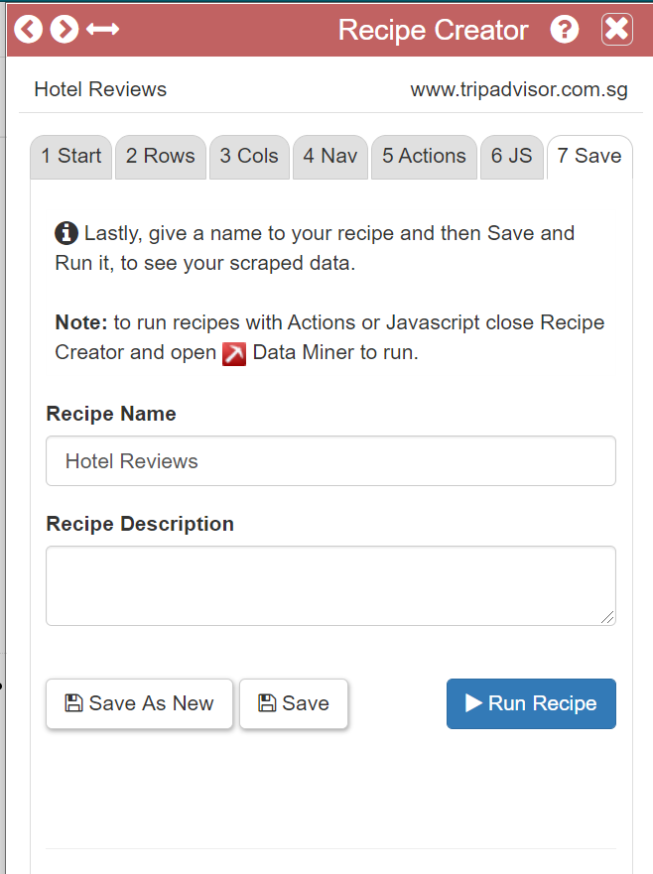

After that name your recipe and then save it so you are able to use it on another page on the same website

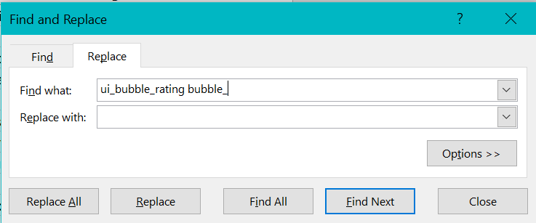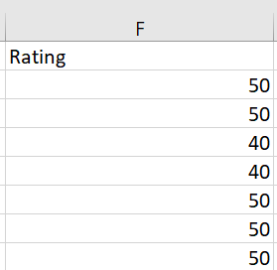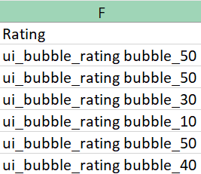

We used the tools in Excel to cleanse the data that we have

First we used the Find and Replace to remove the line of code from the rating so it will be just the numbers

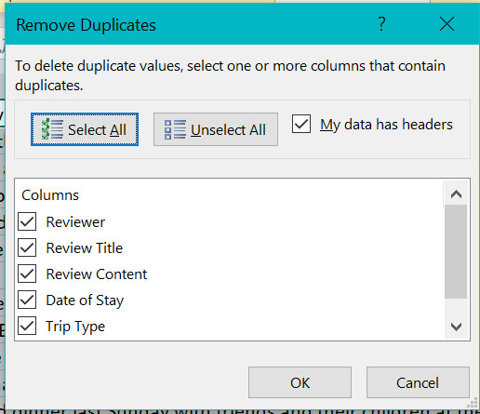

Next we used the Data cleansing to remove any duplicates of date that we had so the data that we were looking through was accurate

## Technical Documentation (Installation guide/Manual)

Go to <https://data-miner.io/>

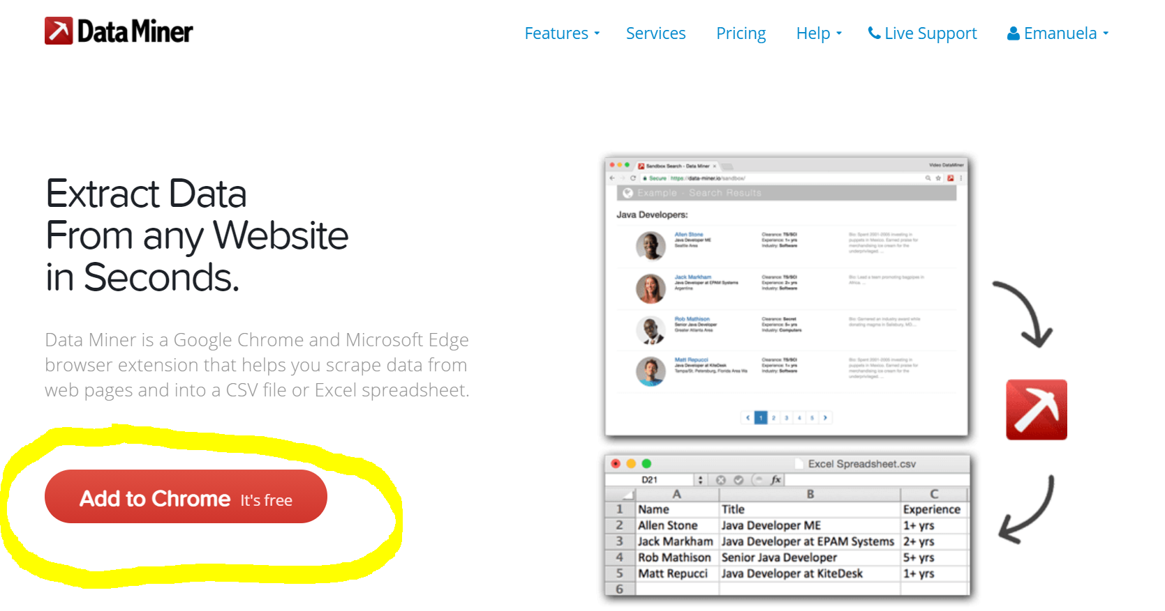

and click on the “Add to Chrome” button and it will lead to this page

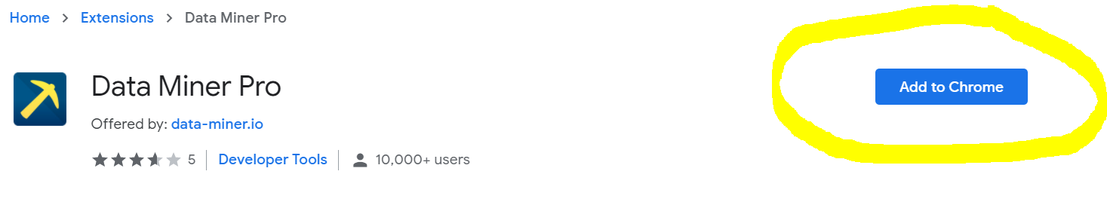

click and “Add to Chrome” and you are all set to use Data Miner.

# Conclusions

***Section Explanation:*** *This is the section where you should state the main take-away points from your project. It should be more information than the abstract. You should include a concise version of your accomplishments, what problems you had, and what could be done in the future to rectify them.*

* *Summary of Accomplishments*
* *Future Work*

*Hotels(Tian Gan)*

*What this project has taught me is the importance of having data and also how important data analytics can be to help a company make business decisions. Data analytics is very important in helping a company make business decisions as they will be making more reasonable decisions based on the data that they have instead of making decisions based on what they think they will happen. From this project I have also learnt the importance of data cleansing, without data cleansing there might be a few duplicate data that if were added into the final summary would be unfair.*

*For what could have done better with this project was to find a better text mining tool so that we are able to text mine my excel file so that we would be able to better utilize my Review Content so that we are able to help the business better understand their data with words instead of just numbers.*

*Shopping Malls(Jolene)*

*My main takeaway from this project was in fact knowing the importance of raw data being processed into usable information as it is widely used everywhere in business organisations. I have also gotten a better understanding on data understanding and data analytics whereby they’re strongly linked to one another. It is actually necessary to understand what insights I am supposed to show the targeted users and put myself in the same position so as to think out of the box. It is important to let the users understand the insights in the simplest way possible. I have accomplished creating a credible storyboard that would be usable by TripAdivsor if they were to show a package to tourists about Singapore's Shopping Malls. The problems that I had were that the Orange PDFs I created did not come to use at all and with the data scraping process. What could be done in the future is that I should find a suitable way to make use of the data that I have gotten from Orange instead of just leaving it aside. For the data scraping,*

*Modes of Transport (Han Yew)*

*All in all, I have understood how essential it is to have IT in one’s business model. It is made easy for consumers or clients to be able to view raw data which is well-tabulated and it makes it very easy for the average person to understand and to absorb the information that is being presented. I have successfully made a storyboard which shows the different modes of transport that are available in Singapore. I have also shown the pricing difference between SMRT and SBS, which attraction is favoured amongst the locals compared to foreigners, which private mode of transport is the most popular and finally, which tour groups are the most worth it to sign up for. With all this essential information, it should give a tourist more than enough knowledge on how to get around Singapore with ease. All the information that I provide is to ensure that a tourist always has more than one option when it comes to transportation in Singapore and they would feel more at ease. Some problems that I faced were that the initial data scraped was not enough and I had to keep going back and forth to extract the data that I needed to structure my business questions in the beginning. There were also a lot of null values that were extracted due to users not inputting any value in the given area, which also caused a lot of problems as null values cannot be tabulated and would affect my overall data. For my future work, I would craft out the possible questions that I have in my mind so as to collect all the data I need and no time would be wasted to keep going back to the website to extract the data. I would also be able to do better dashboards and storyboards from this experience as I have really learnt a lot throughout the whole process, which I am thankful for.*

*Attractions (Syukry)*

*These past 12 weeks or so have taught me about how data analytics is quite a tough skill to do and I can see how it is in such high demand in the job market. I have definitely faced some challenges here and there whereby my Tableau just does not want to save my work or my data sources got tampered with but I learnt that it was all a part of the process for something valuable. The main takeaway that I took was the data scraping skillset which interested me particularly because it gave me the ability to have control over what I wanted to extract information from and that is to me the most important step when it comes to data cleansing and data analytics because if there is no data in the first place, then the whole process cannot occur. Finally, I learnt how to make it convenient for visitors to make an informed decision on which attraction they would want to visit in Singapore. As for future work, this eye-opening experience has definitely increased my interest in the processes carried out in Business Intelligence and is a good stepping stone for future projects that I may or may not wish to partake.*

References

* **Acknowledge** any work, statement or definitions copied
* Citation
* Tarun, Kumar. "10 Biggest Challenges in Data Processing" [Challenges in Data Processing](https://www.loginworks.com/blogs/10-biggest-challenges-in-data-processing/) 2020 Loginworks Softwares

Usage: Some Text.

* Graham Moore, Managing Director of Katchr “How to transform raw data into useful management information” [Transform raw data](https://www.katchr.com/blog/how-to-transform-raw-data-into-useful-management-information/)

Usage: Some Text.

* Megan, Slinn. “Turning Data into Information; Why is it So Important?” [Turning Data into info](https://www.iqmetrix.com/blog/turning-data-into-information-why-is-it-so-important)

Usage: Some Text.

* Charles, Dennis. “Why people shop where they do?” [Marketing Segmentation for Shopping Centres](https://link.springer.com/chapter/10.1057/9780230509481_8)

Usage: Some Text.

# Appendices

***Section Explanation:*** *This is for you to include materials which you could not put in the main body of your report. For example, you could include source code of your project.*

*Appendices should be headed by letters in alphabetical order, ie. Appendix A, Appendix B, etc.*

*Since we did not do coding, this section is irrelevant.*

# Project Poster

***Section Explanation:*** *Pls create a poster write-up for your project. The file should be saved as a PPT file and embedded in this section as an object.*

**